An interface between statutes and salmon: the Legislation Applicable to Pacific Salmon and Ecosystems (LAPSE) framework
Joe Enns, Cory Lagasse, Daniel Gillis, Marina Wright
2026-02-11
Table of Contents

Abstract
Pacific salmon (Oncorhynchus spp.) populations are generally declining in Canada, while the number of populations monitored continues to drop, despite considerable attention towards policies and recovery programs for salmon conservation. Wild-origin salmon abundance declines are recognized as a consequence of numerous aspects of human activity, including the loss or degradation of habitat, climate change, hatchery pressures, and harvest. Addressing these threats requires coordinated action across a fragmented governance landscape where federal jurisdiction over fisheries intersects with provincial authority over freshwater habitat, creating regulatory complexity that impedes effective stewardship. Practitioners often lack accessible frameworks for navigating the legislative architecture governing salmon and their ecosystems. To address this gap, we present the Legislation Applicable to Pacific Salmon and Ecosystems (LAPSE) framework, which is a systematic process and open-source tool that bridges regulatory language with standardized threat classifications. We accumulated 196 Canadian federal and British Columbian provincial statutes relevant to Pacific salmon stewardship and parsed them by individual clause using automated HTML extraction. Using keyword-matching algorithms, we assigned clauses by “management domains” that we define as discrete areas of administrative concern. These management domains align with the International Union for Conservation of Nature–Conservation Measures Partnership (IUCN-CMP) Direct Threats Classification version 4.0. Additionally, we categorized clauses by salmon-specific scope (from direct salmon references to general governance) and clause type (e.g., prohibition, authorization, designation). Our analysis reveals that spatial designation and pollution-related provisions are most prevalent across both jurisdictions. Fisheries (harvest) management of salmon is primarily federal, while water use regulations are mostly provincial, which reflects a structural disconnect between harvest control and habitat protection. Case studies linking Fisheries and Oceans Canada’s (DFO) Recovery Potential Assessment threat rankings for assessed Designatable Units to corresponding legislation demonstrate the framework’s utility for identifying regulatory pathways relevant to specific threats. The LAPSE framework provides salmon stewardship practitioners with navigability of the legal landscape, enabling more informed evaluation of regulatory tools available to address threats and supporting the development of coordinated, inter-jurisdictional recovery strategies.

Introduction

The patchwork of Pacific salmon governance in Canada
Eurocentric colonial stewardship of natural resources in Canada is administered through a decentralized, multi-sector array of federal, provincial, and territorial constitutional authority (Campbell and Thomas 2002; Ray et al. 2021). Stemming from the Constitution Act, legislative control over fisheries and ecological stewardship has been a reactionary process of assigning authority through two orders of government (federal and provincial) for new environmental issues as they arise, which creates a complex and overlapping governance distribution (Becklumb 2013). Provinces have jurisdiction over most wildlife within their borders; however, the federal government has jurisdiction over wildlife on federal land (e.g. national parks), as well as, migratory birds and aquatic species including marine mammals and fish (Becklumb 2013; Kraus et al. 2021). The dual roles – arising from the adaptation of British Common Law to the Canadian situation – can lead to confusion around management prerogatives (Thompson 1974) when jurisdictional authority is rarely the responsibility of one level of government (Campbell and Thomas 2002).
The patchwork of legislative authority is most prominent in Pacific salmon management due to the various populations’ geographically widespread, anadromous life cycles that spans international boundaries and freshwater and marine ecosystems. While salmon populations and salmon fisheries are regulated federally, water use and watercourse alterations and the corresponding aquatic habitat is managed by the provinces. However, watercourse management is not strictly provincial jurisdiction. The federal government regulates navigable waters in oceans, lakes, rivers, and streams even within provincial boundaries (Becklumb 2013; Swerdfager and Olive 2023). Federal fisheries governance also includes the quality of fish-bearing waters, and both federal and provincial governments have authority to designate protected areas.
Acts and regulations in British Columbia might be designed to address one broad category of human activity, but this activity can cover many aspects of salmon stewardship. For example, the provincial Forest and Range Practices Act (Government of British Columbia 2002) is specific to forestry practices and planning, along with cattle ranging, but in terms of salmon threats, these activities impact many aspects including stream hydrology, water temperature, effluent, riparian habitat destruction, watercourse changes, (Ulaski et al. 2025), and the spread of invasive species.
Projects that influence environmental factors may be subject to both provincial and federal environmental assessments during the planning stages (Becklumb 2013). Natural resource legislation and programs often operate on a sector-by-sector and individual resource basis where integrated stewardship relies on scale-appropriate planning and decision making (Ray et al. 2021). Provinces generally decide when, or if, to regulate on matters of environmental concern (Campbell and Thomas 2002). British Columbia is even more decentralized than other provinces, especially in terms of species at risk legislation, because British Columbia’s relevant provisions are spread over the greatest number of statutes and regulations (Bogetti and Mason 2025).

Complexity in addressing Pacific Salmon population declines
Despite considerable attention towards policies and recovery programs for salmon conservation and governance (e.g. Canada’s Policy for Conservation of Wild Pacific Salmon and the Pacific Salmon Strategy Initiative; DFO (2005)), Pacific salmon populations are generally declining across Canada, while the number of populations monitored continues to drop (Price et al. 2017; Atkinson et al. 2024). The causes of Pacific salmon population declines in Canada are varied and have been the subject of numerous major studies and reviews over the last few decades (e.g. the Commission of Inquiry into the Decline of Sockeye Salmon in the Fraser River (Canada) (Cohen 2012); Report of the Standing Committee on Fisheries and Oceans (McDonald 2021); and the State of the Canadian Pacific salmon: response to changing climate and habitats(Grant et al. 2019)).
The wild-origin salmon abundance declines are recognized as a consequence of numerous aspects of human activity, including the loss or degradation of habitat, climate change, hatchery pressures, and harvest (Bisson et al. 2009; Cohen 2012; Grant et al. 2019; and McDonald 2021). In response, commercial fisheries have been curtailed in recent decades (Del Valle et al. 2024) as Fisheries and Oceans Canada (DFO) aims to manage fisheries to preserve biodiversity in a manner consistent with the Wild Salmon Policy and the “precautionary approach” (DFO 2005). Commercial salmon fisheries are one aspect that is directly managed by DFO as legislated under the federal Fisheries Act (Minister of Justice Canada 1985), and subsequent regulations, which prescribe how, when, and where fisheries harvest may occur within Canadian waters with less of the jurisdictional ambiguity. Fisheries also result in a quantifiable mortality of salmon, therefore, impacts and targets can be more accurately measured and managed (assuming adequate monitoring information is collected), and can adjust to changing abundances. This ability to cut fisheries harvest in-season, while the other aspects that impact salmon population productivity and habitat capacity remain and continue to compound, creates a situation where harvest cutbacks (and the corresponding negative economic impacts) have little effect on recovering the salmon populations.
- Cory - do we need more citations for end of this paragraph? Do you have some?
Threats to salmon habitat require a much more coordinated, inter-jurisdictional and inter-departmental approach to evaluate and address. Freshwater habitat, including water quantity (discharge and timing) and water quality (temperature, chemistry, and pollution), are impacted by actions and conditions throughout the entire watershed. Impacts from activities are often indirect, requiring monitoring and long-term studies to identify with confidence (Ulaski et al. 2025). Local activities, such as forestry, agriculture, and urbanization, act cumulatively and compound with climate changes to degrade salmon watersheds (Moore et al. 2025) such that the regulation of threats to salmon freshwater habitat in British Columbia requires the application of multiple acts and regulations across both federal and provincial jurisdiction, where the impacts from activities and the benefits of mitigation are uncertain and spread out over time and space. For example, terms specific to pollution (effluent, wastewater, deleterious substances, etc.) occur in 18 Canadian federal acts and 22 British Columbian provincial acts, where the implementation of these acts are the responsibility of eight Canadian federal ministries and nine British Columbian provincial ministries (Province of British Columbia 2025; Department of Justice Canada 2026).
- Marina - I revised the paragraph to hopefully summarize what you’d suggested in your comment. My original paragraph was vague and unfinished. We don’t really mention specific gov’t branches and structures since they can change arbitrarily. Hopefully, this still covers what you were recommending.
Assessment frameworks have been developed amidst this uncertainty and complexity to evaluate anthropogenic activities and limiting factors for the survival and recovery of Pacific salmon populations (Salafsky et al. 2008; DFO 2021; Chalifour et al. 2022). These frameworks are varied in their approaches, but aim to be comprehensive in assessing the wide range of concerns that may impact salmon across their life cycle to inform status assessments, recovery planning, and conservation strategies. One widely used risk assessment framework for Pacific salmon is the International Union for Conservation of Nature (IUCN) and Conservation Measures Partnership (CMP) Direct Threats Classification (Salafsky et al. 2008), which is applied for Recovery Potential Assessments as part of Species at Risk Act listing processes and for Committee on the Status of Endangered Wildlife in Canada (COSEWIC) status assessments (Arbeider et al. 2020; Dionne 2023; Doutaz et al. 2023).
Rebuilding plans have been developed under the Fisheries Act Fish Stock Provisions (DFO 2022a) for a small number of Pacific salmon populations including Okanagan Chinook (DFO 2022b) and West Coast Vancouver Island Chinook (DFO 2025). Risk assessments are intended to guide the development of rebuilding plans and mitigation actions with the ultimate aim of reversing declines and improving conservation status, assuming there is agreement upon the most important threats. A key challenge is identifying actions that are impactful and feasible across the wide geographic range and diverse life history of Pacific salmon. In many cases, dispersed authority, regulatory complexities, ambiguous responsibilities, ill-defined standards of management, and unclear conservation objectives across jurisdictions become barriers to effective and timely action.

Why study salmon legislation: purpose and objectives
The need for collaborative, coordinated action to address Pacific salmon declines is recognized by governments throughout policies, plans, and initiatives including the Wild Salmon Policy (DFO 2005) and the Trilateral declaration on the urgent need to address wild Pacific salmon populations in British Columbia (DFO 2024). Coordinated action requires adequate organizational capacity and systems for implementation to ensure that regulatory controls and mitigation activities address underlying threats to salmon and their habitat. However, linking threats and recovery actions to the relevant regulatory systems can be complex because salmon are often affected by multiple threats that each span across agencies and governmental jurisdiction. In this study, we seek to decode the complexity between threats to salmon and corresponding environmental legislation by creating an interface between regulatory language and anthropogenic threat categories.
Laws formally codify societal values and expectations (Swerdfager and Olive 2023) by governing human activity. Salmon population management administered through legislative authority, therefore, relies on a tertiary system where laws control human activity, which impacts the quantity and quality of salmon habitat, which affects the capacity of the habitat to produce salmon. Because this system of control pivots around human activity, we also focused this study and tools around human activity, employing the hierarchical categorization structure developed by the IUCN-CMP. However, not all aspects of salmon management are specific to threats from human activity. Topics such as restoration, species status, spatial designation (parks), and overall governance administration may not connect to a direct human threat, or may encompass all the threats. In order to capture all these threat and non-threat related categories in our legislation-salmonscape interface, we created a schema of “management domains” that we define as “discrete areas of administrative concern.”
We developed and outlined the Legislation Applicable to Pacific Salmon and their Ecosystems (LAPSE) as a process and tool to parse Canadian federal and British Columbian provincial acts and regulations relevant to Pacific salmon, then use keyword phrase relationships to match clauses (paragraphs) to our management domains and corresponding IUCN-CMP threat categories. By creating an extensive, open-source, and accessible database linking legislation to salmon, we aim to facilitate a better understanding of the legislative and regulatory context through which salmon and their ecosystems are governed in British Columbia, while providing a framework to support systematic and critical reviews of strengths and shortcomings of regulations with respect to salmon threats.

Management domains and the International Union for Conservation of Nature- Conservation Measures Partnership threat categories
Salafsky et al. (2008) recognized that using a common language and a standard lexicon is essential for conservation science. Threats are a fundamental conservation concept, and can be defined as “current or future human activities or altered natural phenomena that affect one or more ecosystems or species of interest” (Salafsky et al. 2024). Legislated recovery planning also relies on a description of identified threats (McCune et al. 2013). The IUCN and the CMP began developing classifications of direct threats in the early 2000s, which were then compiled and developed further through an iterative process resulting in the IUCN – CMP Direct Threats Classification Version 4.0 (Salafsky et al. 2024) used for this exercise. The IUCN Direct Threats Classification uses a hierarchical, exclusive, comprehensive, and expandable structure of three levels similar to the Linnean system of grouping by family, genera, and species (Salafsky et al. 2008). First-level categories (Level 1) are the broadest, and are subdivided into second-level categories (Level 2), which are further subdivided into the most specific, third-level categories (Level 3).
Canadian and British Columbian legislation has been enacted on a sector-by-sector basis, which doesn’t exactly align well with the IUCN-CMP Level 1 categories. The IUCN-CMP Level 2 categories fit well with corresponding management domains and legislative categories; however, could be grouped for simplicity and to be more intuitive (Figure 1). IUCN-CMP Level 3 categories were not used in this assessment.
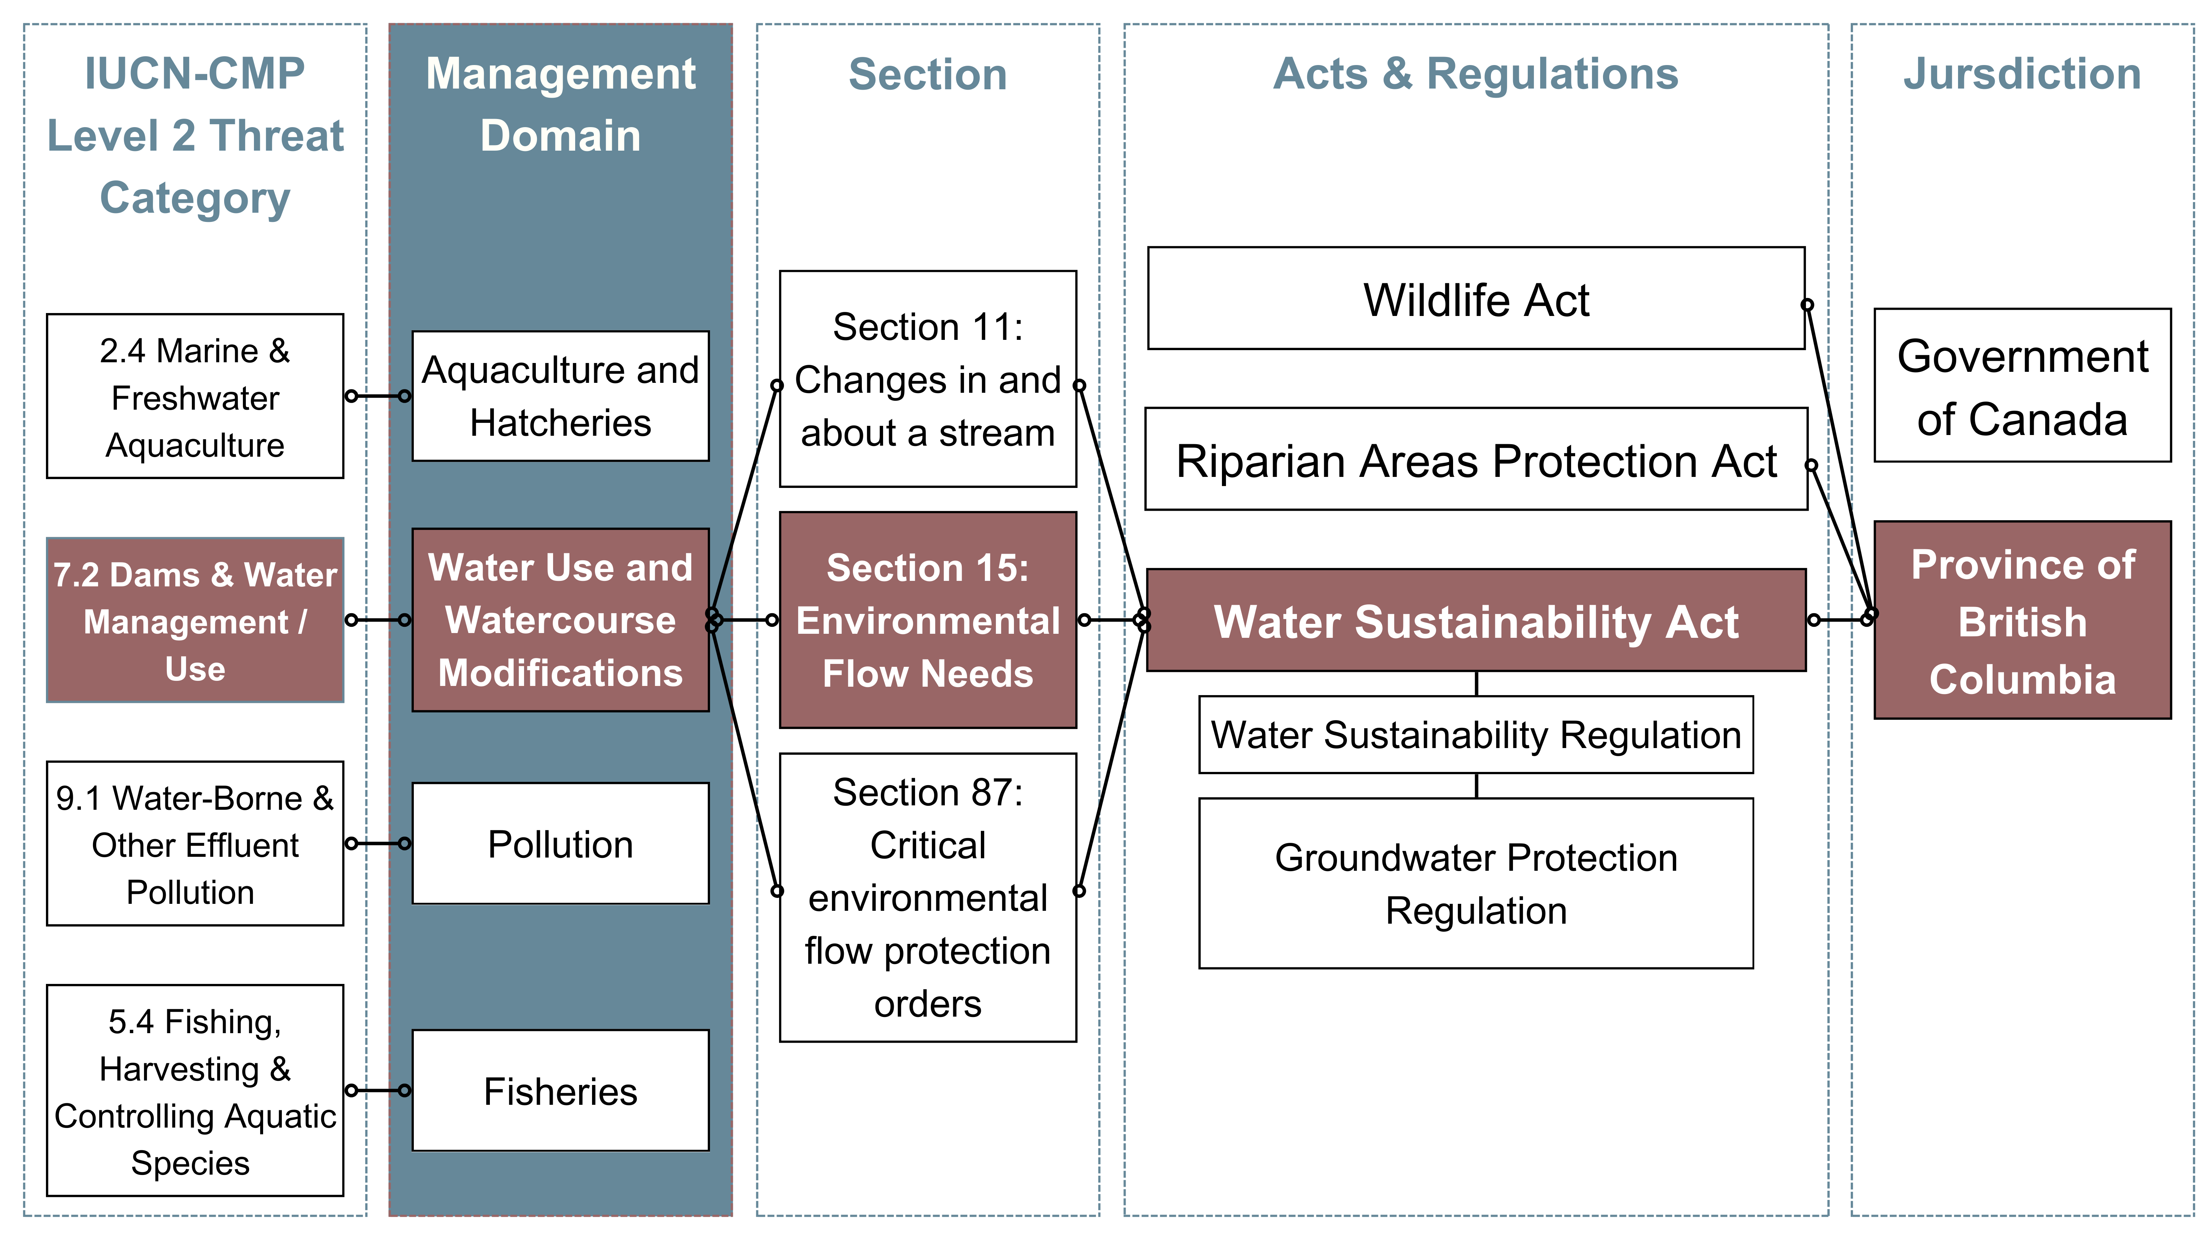
Figure 1: Flowchart showing alignment of IUCN-CMP Level 2 threat categories with Management Domain in relation to legislation and jurisdiction.
Lumping and splitting between IUCN-CMP Levels 1 and 2 categories was required to match threats with legislation (Table 1), which is why the management domain categories were required. For example, aquaculture and hatcheries are important aspects that impact Pacific salmon populations. This topic spans two IUCN-CMP Level 1 categories: 2. Agriculture & Aquaculture and 8. Invasive / Other Problematic Species, Genes & Pathogens, but would be more specifically aligned with the IUCN-CMP Level 2 categories: 2.4 Marine & Freshwater Aquaculture and 8.3 Introduced Genetic Material. For clarity and better alignment, we created a management domain called Aquaculture and Hatcheries. A similar misalignment occurs when assessing the provincial Forest And Range Practices Act. Since the management domain categories were derived as close as possible to the IUCN-CMP threat categories (a mix of Level 1 and Level 2), most can be viewed as equivalent.
Table 1: Management domains and corresponding IUCN - CMP threat categories.
Management Domain | IUCN-CMP Level 2 | IUCN-CMP Level 1
Agriculture | 2.1 Annual & Perennial Non-Timber Crops | 2. Agriculture & Aquaculture
Aquaculture and Hatcheries | 2.4 Marine & Freshwater Aquaculture
 | 8.3 Introduced Genetic Material | 8. Invasive / Other Problematic Species, Genes & Pathogens
Climate Change and Natural Disasters | 10.1 Geological Events | 10. Natural Disasters
 | 11.2 Changes in Temperature Regimes | 11. Climate Change
 | 11.3 Changes in Precipitation & Hydrological Regimes
Fisheries | 5.4 Fishing, Harvesting & Controlling Aquatic Species | 5. Biological Resource Use & Control
Forest and Range | 2.2 Wood & Pulp Plantations | 2. Agriculture & Aquaculture
 | 2.3 Terrestrial Animal Farming, Ranching & Herding
 | 5.3 Logging, Harvesting & Controlling Trees | 5. Biological Resource Use & Control
Human Disturbance | 6.3 Other Human Disturbances | 6. Human Intrusions & Disturbances
Invasive or Problematic Species and Disease | 8.1 Invasive Non-Native / Alien Species | 8. Invasive / Other Problematic Species, Genes & Pathogens
 | 8.2 Problematic Native Species
 | 8.4 Pathogens
Mining and Energy | 3.1 Oil & Gas Exploration & Extraction | 3. Energy Production & Mining
 | 3.2 Mining & Quarrying
 | 3.3 Renewable Energy
Pollution | 9.1 Water-Borne & Other Effluent Pollution | 9. Pollution
 | 9.2 Garbage & Solid Waste
Transportation Infrastructure | 4.1 Roads, Trails & Railroads | 4. Transportation, Service & Security Corridors
 | 4.2 Utility & Service Lines
 | 4.3 Shipping Lanes
Water Use and Watercourse Modifications | 1.1 Residential Areas | 1. Residential, Commercial & Recreation Areas
 | 7.2 Dams & Water Management / Use | 7. Natural System Management & Modifications
 | 7.3 Earth & Sediment Management
 | 7.5 Biological System Management
Restoration | NA | NA
Spatial Designation | NA
Species Status and Assessment | NA

Parsing legislation: a process for clause categorization
Assessment of legislative context is prone to subjective interpretation. The inclusion and exclusion of both the overall acts and the clauses within the acts creates points of assumption and bias. For this exercise we cast as wide a net as possible and created a process that is publicly accessible, automated, and repeatable if legislation changes. The process steps are: 1) accumulate and review legislation (CanLII); 2) parse legislation by clause (paragraph), section, and heading; 3) match management domain and IUCN-CMP threat keywords to clauses; 4) assign salmon-specific scope categories; 5) match clause type keywords to clauses.

Legislation accumulation and review
Administrative concerns specific to natural resource stewardship are also often split between ministries at the federal and provincial level, which can further decentralize responsibility. Figures 2 and 3 show a compilation of federal and provincial acts relevant to Pacific salmon stewardship with assigned ministries. Relevant acts were compiled through a step-wise keyword search process using the Canadian Legal Information Institute (CanLII) website (Canadian Legal Information Institute 2025). The ministries were referenced from the federal Table of Public Statutes and Responsible Ministers (Department of Justice Canada 2026) and the British Columbian provincial Acts - Minsters’ Responsibilities (Province of British Columbia 2025). The ministry and minister names shown may not necessarily represent the current cabinet names, which can be changed arbitrarily by the government of the day. The table represents the minister and ministry names as they are stated in the legislation and corresponding minister responsibility tables, which are less prone to short-term changes.
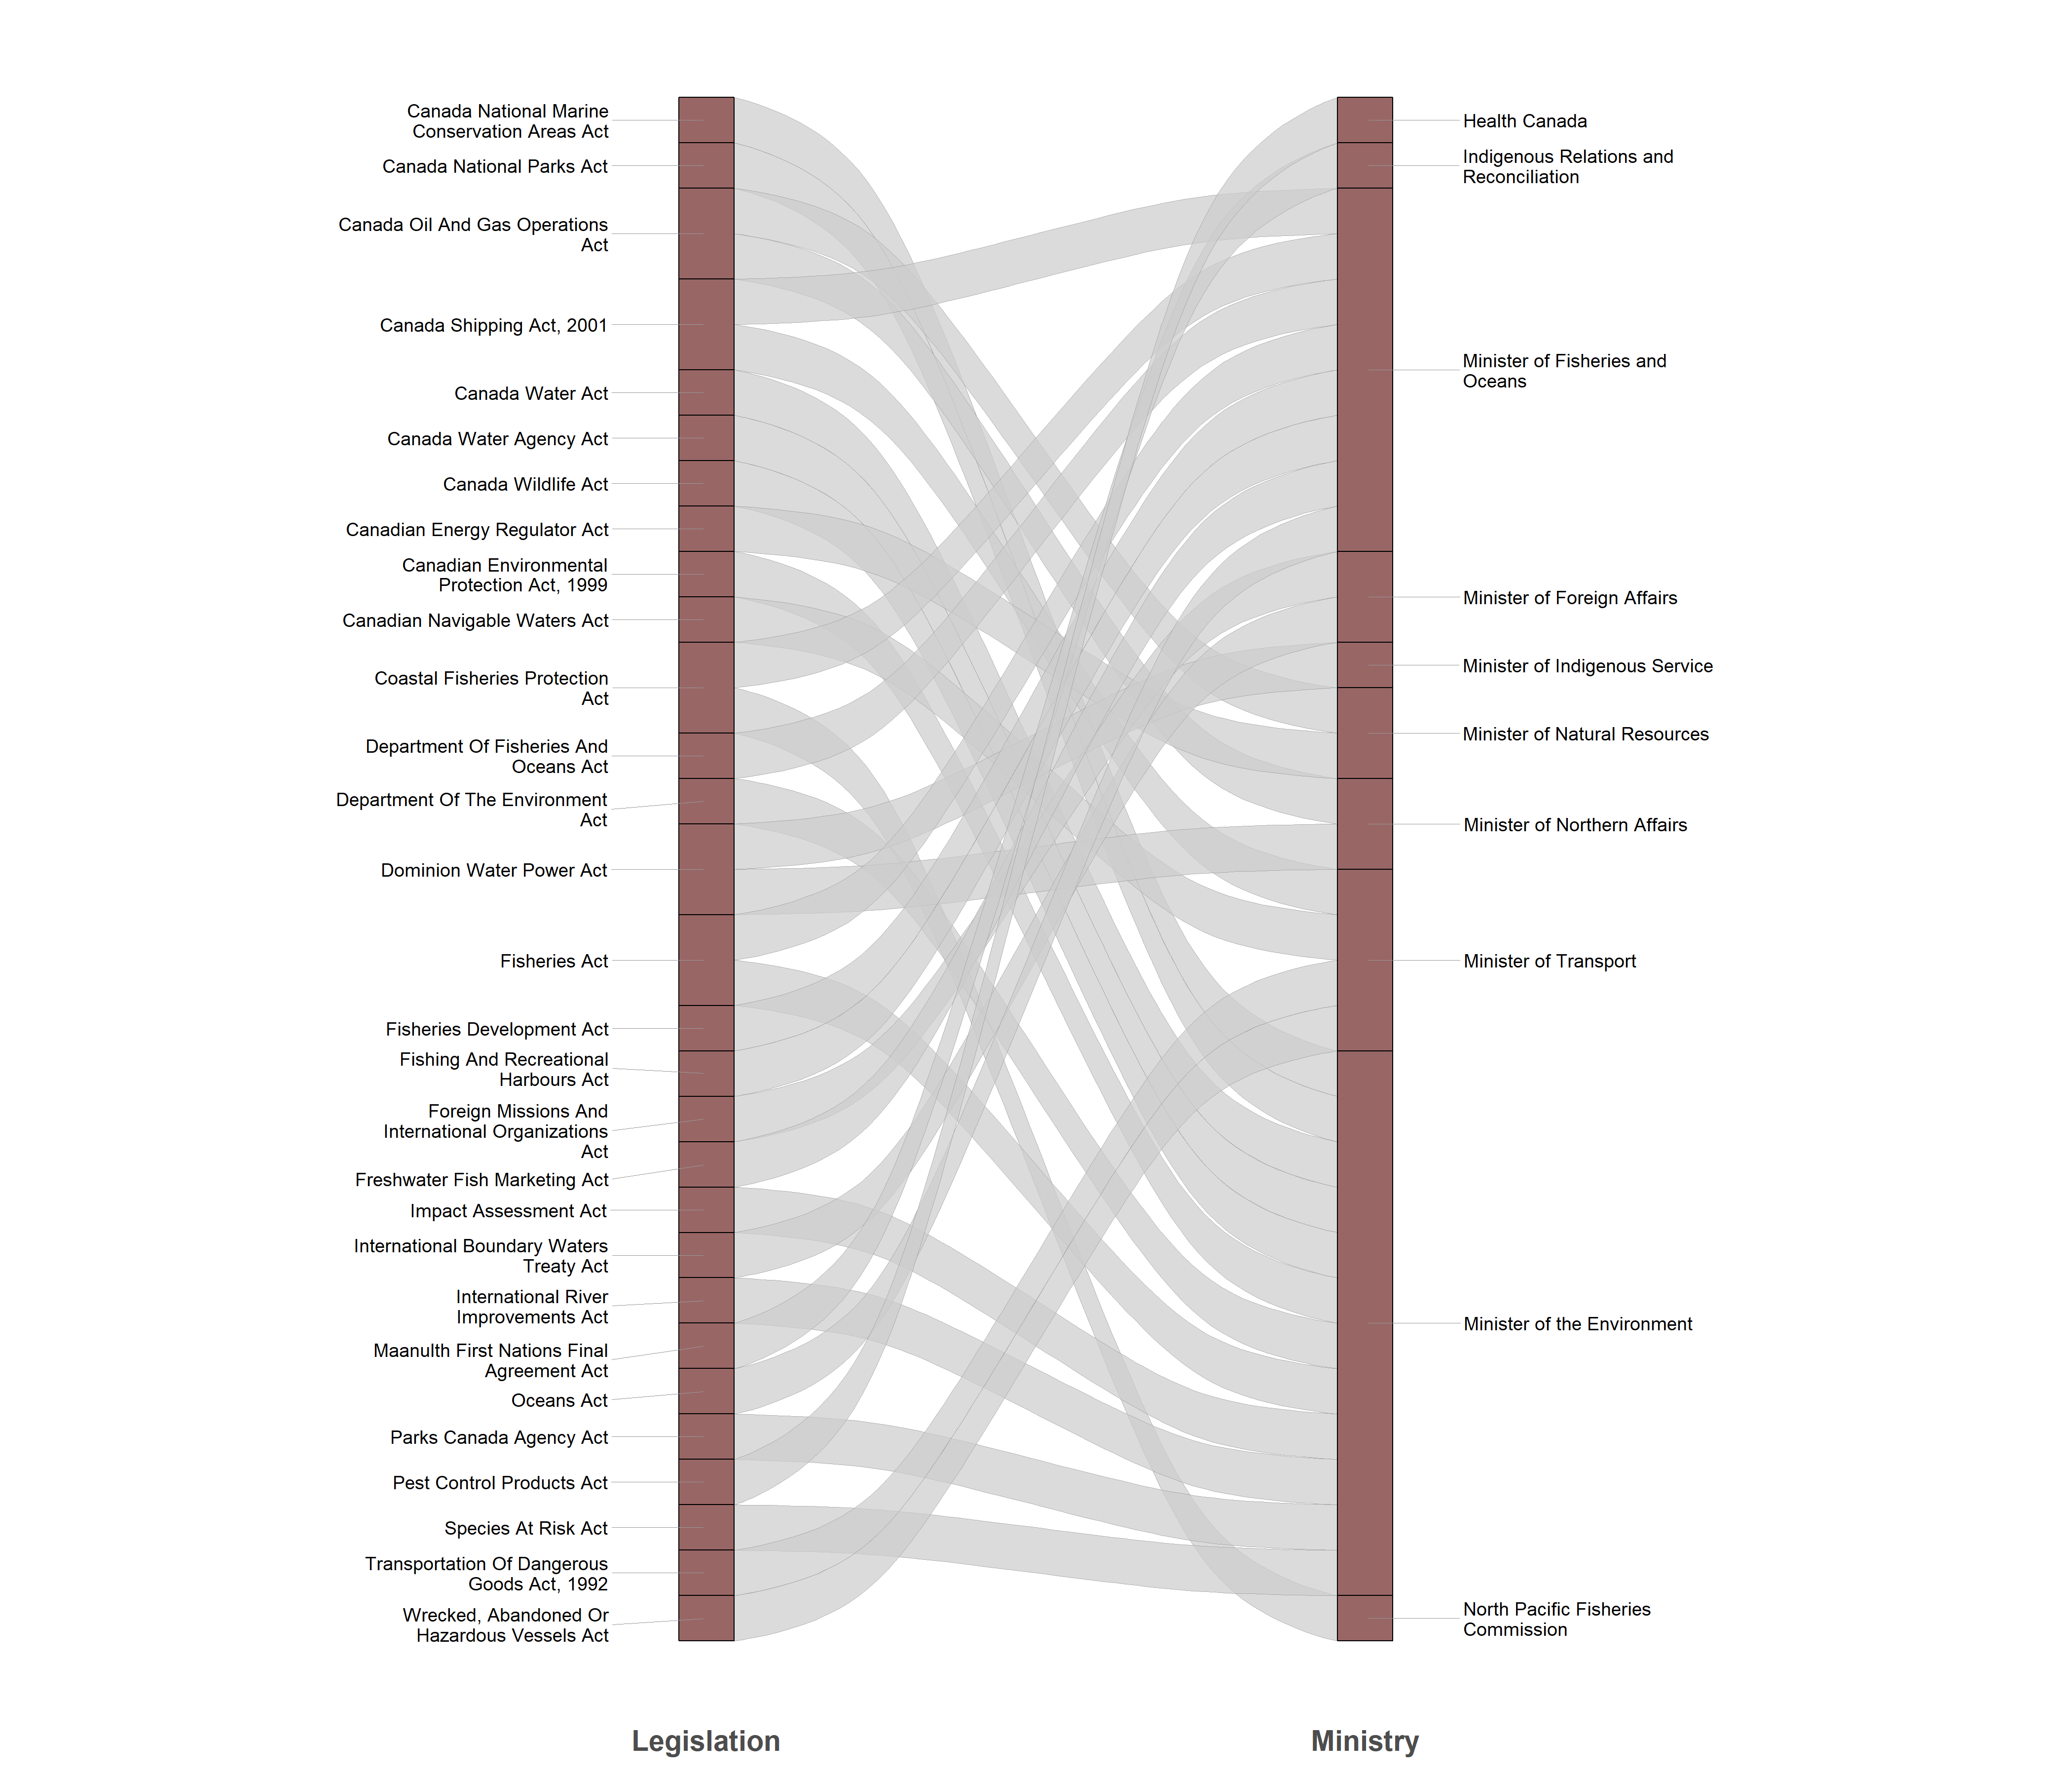
Figure 2: List of Canadian federal acts relevant to Pacific salmon and habitat governance with assigned ministries.
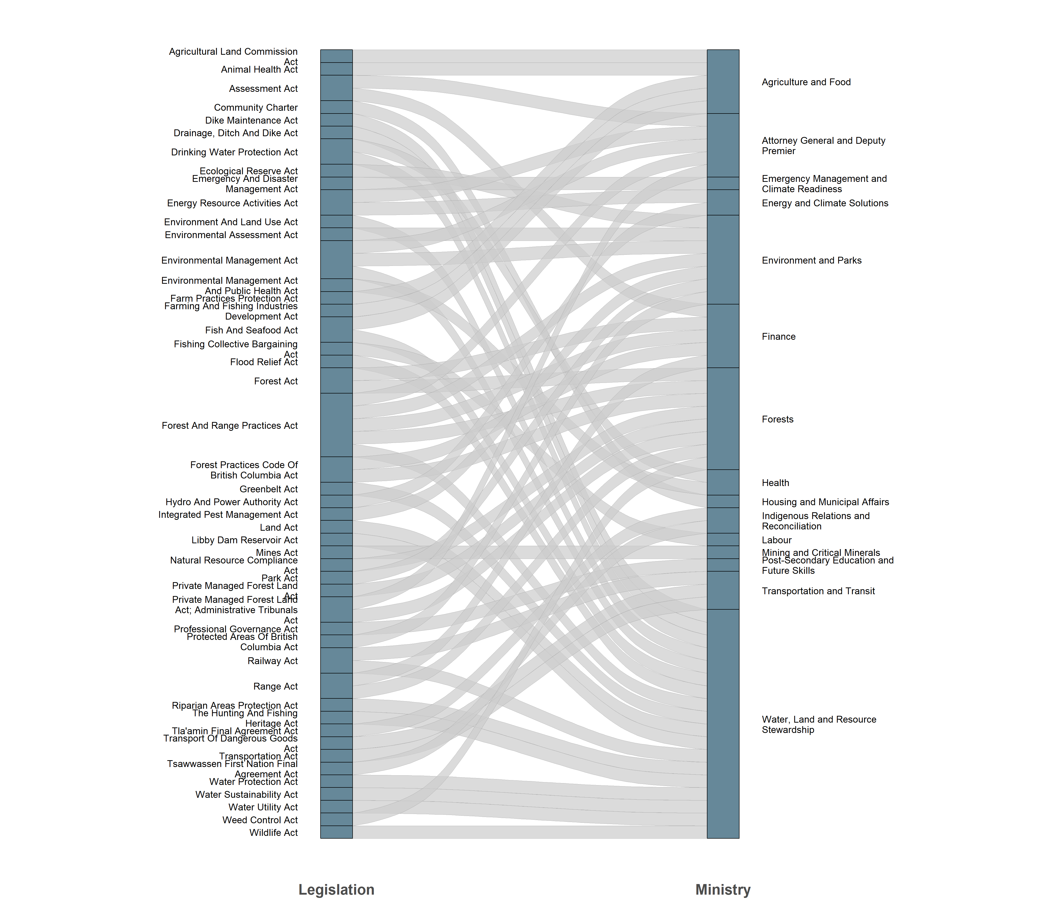
Figure 3: List of British Columbian provincial acts relevant to Pacific salmon and habitat governance with assigned ministries.
We accumulated Canadian federal and British Columbian provincial legislation according to their relevance to Pacific salmon and habitat stewardship. For this study, the term legislation (or statutes) refers to acts, regulations, codes, and orders. Policies are formal statements about how the government of the day plans to execute the legislative requirements (Marentette and Kronlund 2020). Legislation is a better indicator of a jurisdiction’s long-term commitment to natural resource stewardship (Bogetti and Mason 2025) than policies because policies are more prone to changes in the political, administrative, and budgetary landscape, while legislation is subject to due process or a parliamentary vote. Specific departmental policy frameworks and processes were not assessed within this exercise. This study also does not verify the implementation or enforcement in practice of the accumulated statutes by the responsible officials. The accumulated legislation is simply shown as it is written.
Indigenous legislation, Yukon Territorial legislation, municipal bylaws, and international conventions were also not included explicitly. Although this other legislation is pivotal in the stewardship of Pacific salmon, this regionally diverse administration was outside the scope of this legislative review in terms of feasibility and timelines. However, some of these other conventions may overlap with federal or provincial legislation in their governance. For example, the provincial Spheres of Concurrent Jurisdiction — Environment and Wildlife Regulation under the Community Charter references municipal jurisdiction in relation to the environment and wildlife.
The Canadian Legal Information Institute website, CanLII (Canadian Legal Information Institute 2025), provides an excellent resource for searching federal and provincial legislation by keyword search. We used CanLII through a step-wise, systematic process to query salmon-specific terms (salmon, Chinook, sockeye, etc.). Often, popular language and phrasing used by practitioners may not appear in legal language due to the age and generality of the documents. In order to capture salmon-specific language that actually occurs in the legal language, we extracted other adjacent keywords and phrases from the salmon-specific legislation using a word frequency analysis with the “udpipe” R package (Wijffels 2025). A list of extracted adjacent keywords and phrases were combined with the IUCN threat description wordings, which were then queried in CanLII. The user may quickly view each individual keyword within the chosen statute through the CanLII website. This allows the user to assess the context of the word in the legislation and determine if the section might be relevant to Pacific salmon. Legislation was filtered by region (excluding provinces other than BC), and the statutes’ HTML files were downloaded directly from government websites. The number of statutes collected for inclusion in this study is shown in Table 2.
Table 2: Count of legislation by jurisdiction and legislation type.
Jurisdiction | Act | Regulations | Order | Code | Total
Federal | 29 | 51 | 7 | 0 | 87
Provincial | 44 | 63 | 0 | 2 | 109
Total | 73 | 114 | 7 | 2 | 196

Legistics
The decentralized overlapping patchwork of Pacific salmon legislation in Canada creates a dynamic such that each act and regulation may contain a variety of administrative responsibilities, possibly attributed to different agencies. However, each act and regulation is comprised of sections and subsections that contain individual clauses that are more specific to a particular management domain topic. Typological device structure and definitions used in this exercise were derived from the Government of Canada’s “Legistics Paragraphing” (Department of Justice Canada 2022). For the purpose of this review, we used the individual clause (Figure 4) as the sample unit for assignment into management domains and other attributes.
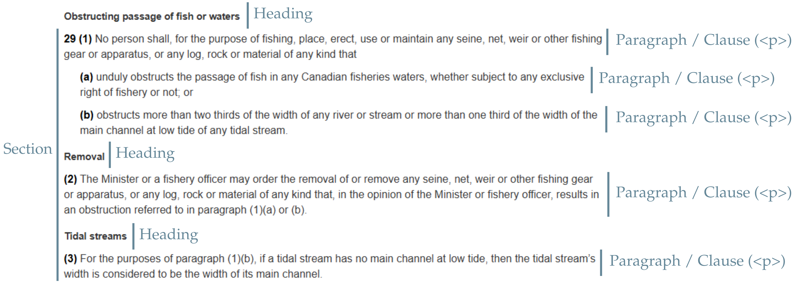
Figure 4: Example of HTML code paragraph parsing structure for Section 29 of the Canadian federal Fisheries Act.
Legislation presented on Canadian and British Columbian government websites, and corresponding HTML code, is structured such that each clause is separated individually as a paragraph element. HTML code for paragraph elements is generally consistent across legislation, but section, subsection, and heading elements are not. As shown in Figure 4, “clause” in this study can also refer to subclauses, but also sections, subsections, and opening words (chapeau or umbrella) when they are stand-alone paragraph elements. HTML files were parsed using R and the “rvest” package (Wickham 2025), extracting the text of each clause, then grouping by section and heading.

The LAPSE process and tool development
The parsed legislation was stored in a SQLite database with datatables including jurisdiction, act name, legislation name, legislation type, paragraph content, section, heading, management domain, IUCN-CMP threat category, scope, and keywords matched. Storing the data as a database rather than one large spreadsheet allowed for a more dynamic and versatile system for querying, while streamlining the parsing and collection process.

Keyword and keyphrase development
The management domain and IUCN-CMP threat matching process pivoted around an established list of keywords and phrases relevant to Pacific salmon stewardship. Keywords act as the language link between categorization and the legislative clauses. Keywords must be specific enough to match an IUCN-CMP threat, yet general enough to appear in multiple acts and regulations that span many decades of legal language. We derived keyword lists from the IUCN - CMP Direct Threats Classification 4.0 examples and definitions; word frequency analyses (unigrams, bigrams, and trigrams) of collected legislation; and iterative researcher input and revision.
The keyword and keyphrase development process required an iterative researcher revision step because of the varied context of language. While the words used in the IUCN-CMP threat definitions may be specific to those threats, they may not be relevant to salmon stewardship and may also have multiple meanings leading to an over-assignment of categories. For example, the word “landfill” is listed on the IUCN-CMP threat examples for 1.2 Commercial & Industrial Areas, in the context of the physical footprint of landfill sites. Much of the collected legislation deals with pollution, in which landfills are mentioned as a source of effluent. However, for salmon habitat, the main threat would come from water effluent, rather than the physical impact of landfill sites adjacent to salmon habitat, and pollution would be a more accurate designation. “Landfill” as a keyword adds many clauses that could be considered outside of the scope of this tool, and so “landfill” was removed from the keyword list. Conversely, the word “riparian” is very relevant to salmon habitat stewardship in British Columbia, yet that word doesn’t appear in the IUCN-CMP threat examples or word frequency analyses of other legislation. “Riparian” was added as a keyword solely from the researchers’ discretion.
Researcher subjectivity can influence the process on two fronts: legislation inclusion, and keyword list development. However, using keyword lists allows for the subjectivity to be acknowledged, and the keyword lists to be reported such that the process may be repeatable. The meaning and context behind keywords, especially single words, can cause mis-categorization in unexpected ways. For example, the word “stock” is an important keyword for salmon stewardship (the Fisheries management domain category). However, as a single word, “stock” can also refer to business holdings, freight cars, and cattle, which do not fit the Fisheries management domain. Revision of “stock” as a keyword is important for the accuracy of categorization. Outputs were reviewed iteratively, and keyword revision was a continuous process to find more relevant bigram or trigram alternatives; remove keywords where sections are already matched with other, more applicable keywords; and search for more specific word variations (plural, past tense, etc.)

Results

Management domains
While the number of statutes, sections, or clauses is not a measure of the quality or effectiveness of the legislation (Ray et al. 2021), the LAPSE process and tool can be used by practitioners to view the existing acts, regulations, orders, and codes when considering actions or proposals. Management domains were identified within all the collected statutes. Spatial Designation and Pollution were the management domains with the highest section count (Figure 5), split almost evenly between federal and provincial jurisdictions. Human Disturbance (specifically, 6.3 Other Human Disturbances, as in species research activities) and Climate Change and Natural Disasters had the fewest section count. Fisheries was in the top five for section count, with a majority of sections under federal jurisdiction. Water Use and Watercourse Modifications was in the top three for section count, with a majority of sections under provincial jurisdiction. This count indicates an underlying possibly dysfunctional relationship where salmon harvest is controlled federally while habitat aspects are governed provincially.
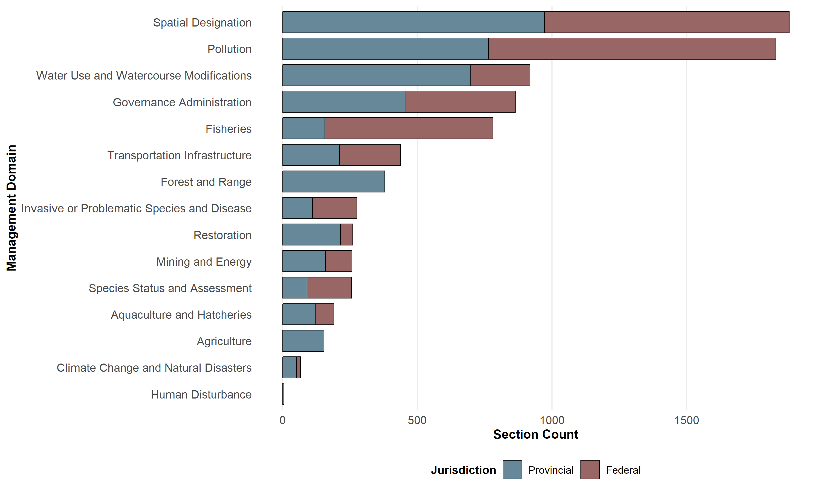
Figure 5: Count of sections matched by management domain, stacked by jurisdiction.

IUCN-CMP Level 2 threats
IUCN-CMP Level 2 categories are more specific, and the categorization process matched to 25 categories (Figure 6) that parallel the management domain categories. Multiple IUCN-CMP threats can comprise a management domain; however 9.1 Water-Borne & Other Effluent Pollution matched with the highest number of sections followed by 7.2 Dams & Water Management / Use and 5.4 Fishing, Harvesting & Controlling Aquatic Species. This assessment shows the proportional layout of historic legal attention given to topics, where pollution receives a large amount of attention, while topics such as temperature changes receives very little legal attention.
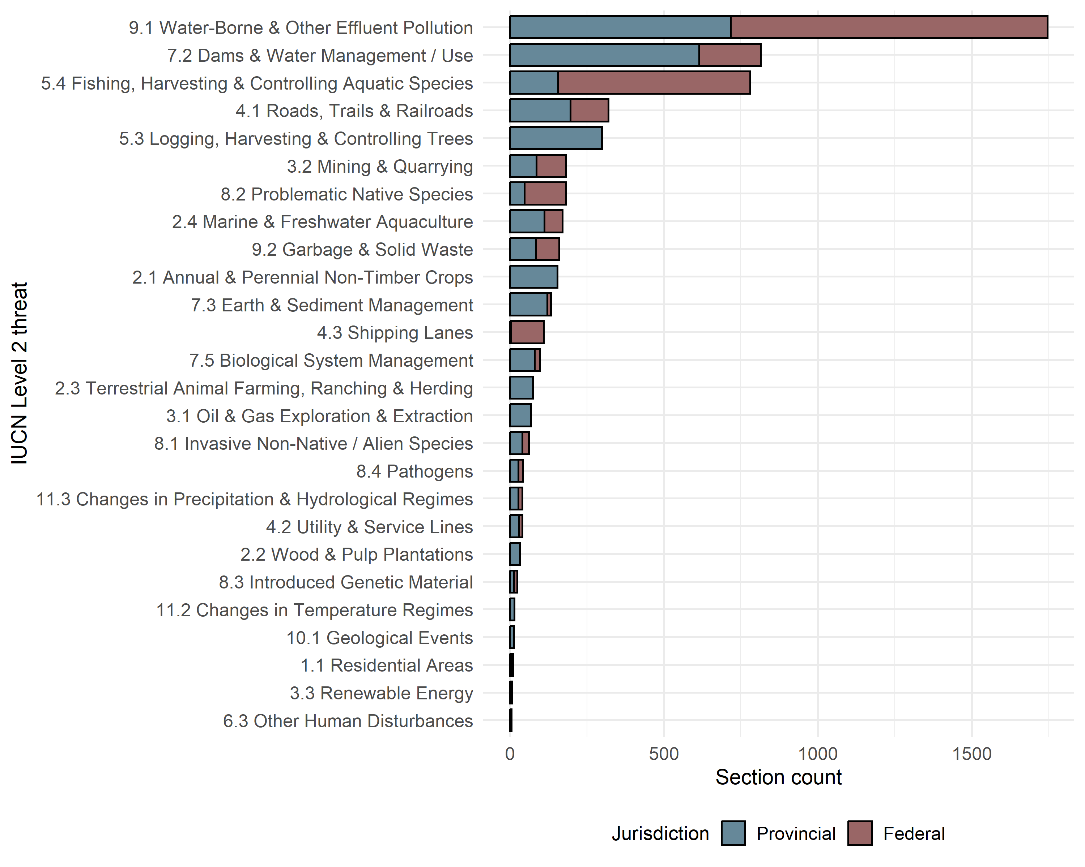
Figure 6: Section counts by IUCN-CMP threat category, separated by jurisdiction.

Salmon-specific scope
Regulatory language that can be matched to management domain and IUCN-CMP threat categories is not inherently relevant to Pacific salmon. However, clauses fall within a relevance spectrum. For example, a clause that states catch limits for Chinook salmon would be much more specific to salmon stewardship than a clause that states that a minister shall include ecological integrity objectives in a park management plan. Both clauses influence salmon governance and stewardship, but one clause is more direct. A “scope” classification was developed as part of this study to parallel management domains and categorize clauses based on their direct application to Pacific salmon. Scope categories were determined by the specificity of the keywords and defined as: “1 – Salmon” (refers to Pacific salmon specifically); “2 – Fish” (refers to fish that include salmon); “3 – Habitat” (refers to any habitat that includes salmon habitat); and “4 – Governance” (refers to administrative processes and structure).
The scope assignment process was linked, but occurred independent of the management domain and IUCN-CMP threat assignment process. The “1 – Salmon” scope was assigned based solely on salmon keywords (salmon, Chinook, sockeye, etc.), regardless of management domain or IUCN-CMP threat. The “2 – Fish” and “3 – Habitat” scopes align directly to IUCN-CMP threats (unless already classified as “1 – Salmon”). The “4 – Governance” scope was applied last in a separate matching process. Language specific to Pacific salmon management was found in far fewer sections than indirect, less specific language (Table 3). More federal legislation sections matched with salmon harvest categories than provincial.
Table 3: Count of statutes, sections, and clauses by scope category.
Scope | Statutes | Sections | Clauses
1 - Salmon | 19 | 71 | 439
2 - Fish | 100 | 941 | 3,389
3 - Habitat | 173 | 3,449 | 15,647
4 - Governance | 180 | 2,622 | 9,192
Total | 196 | 7,083 | 28,667
Pacific salmon-specific language (“1 - Salmon”) also matched more federal statutes (Figure 7, specifically, the British Columbia Sport Fishing Regulations, 1996; National Parks of Canada Fishing Regulations; and Pacific Fishery Regulations 1993. The federal Fisheries Act does not use the word “salmon” or any salmon-specific keywords at all, only the regulations made under the Fisheries Act.
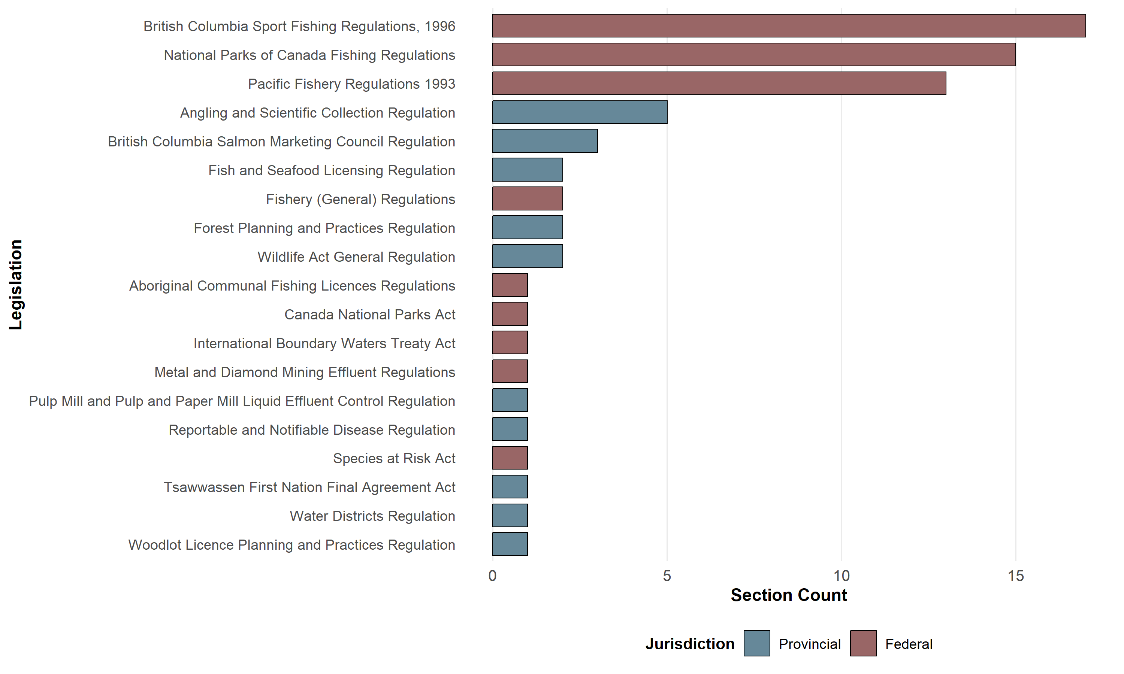
Figure 7: Count of sections by legislation for scope category ‘1 - Salmon’, coloured by jurisdiction.

Clause types as legislative factors
The process of parsing legislation by clause and section, then matching categories by keywords also allows for other possible categorizations. Similar to management domains and IUCN-CMP threats, the nature of the clauses was also matched in terms of the “clause type” (Table 4). Clauses, in general, fit into groupings by their context and the nature of their intent. For this exercise, the categories and keywords were developed solely by the researchers through a subjective process.
Table 4: Section counts by management domain and clause type.
Management Domain | Admin. | Auth. | Desig. | Instr. | Interp. | Licence | Prohib. | Total
Pollution | 253 | 621 | 648 | 865 | 677 | 557 | 327 | 3,948
Spatial Designation | 274 | 718 | 755 | 537 | 555 | 538 | 343 | 3,720
Water Use and Watercourse Modifications | 125 | 353 | 355 | 339 | 349 | 255 | 178 | 1,954
Fisheries | 91 | 297 | 187 | 292 | 196 | 334 | 288 | 1,685
Governance Administration | 97 | 498 | 250 | 224 | 190 | 135 | 123 | 1,517
Forest and Range | 57 | 126 | 164 | 251 | 156 | 189 | 51 | 994
Transportation Infrastructure | 51 | 132 | 138 | 139 | 128 | 131 | 60 | 779
Invasive or Problematic Species and Disease | 54 | 108 | 65 | 110 | 93 | 63 | 54 | 547
Restoration | 23 | 83 | 91 | 93 | 97 | 78 | 45 | 510
Mining and Energy | 27 | 76 | 82 | 108 | 70 | 94 | 31 | 488
Species Status and Assessment | 17 | 90 | 69 | 96 | 81 | 53 | 22 | 428
Agriculture | 30 | 65 | 39 | 32 | 50 | 62 | 44 | 322
Aquaculture and Hatcheries | 20 | 53 | 43 | 51 | 56 | 64 | 28 | 315
Climate Change and Natural Disasters | 4 | 20 | 28 | 20 | 16 | 13 | 4 | 105
Human Disturbance | 0 | 2 | 1 | 0 | 3 | 2 | 0 | 8
Total | 1,123 | 3,242 | 2,915 | 3,157 | 2,717 | 2,568 | 1,598 | 17,320
Abbreviations: Admin. = Administration, Application, & Structure; Auth. = Authorization & Mandate; Desig. = Designation; Instr. = Instruction; Interp. = Interpretation & Purpose; Licence = Licence, Permitting, & Exemptions; Prohib. = Prohibition, Restriction, or Limitation.

Co-occurrence of management domains
The LAPSE keyword matching process allows that multiple management domains (and IUCN-CMP threats) can be matched to clauses and sections. For example the provincial Land-based Finfish Waste Control Regulation (Environmental Management Act) states in Section 2 that: “The owner of a land-based finfish facility is exempt from section 6 (2) and (3) of the Environmental Management Act with respect to the discharge of wastes from the land-based finfish facility if the owner…” Keywords in this clause matched appropriately with both the “Aquaculture and Hatcheries” and “Pollution” management domains. Assigning only one management domain would over-simplify the classification in terms of salmon management as the clause clearly references both aquaculture and pollution. This section could be important for users searching either aquaculture or pollution regulations for a particular watercourse. This dynamic is not a flaw, but rather a way of showing the complexities of legal language as related to salmon stewardship. Domain co-occurrence within sections allows for an interesting study of how management domains overlap (Figure 8).
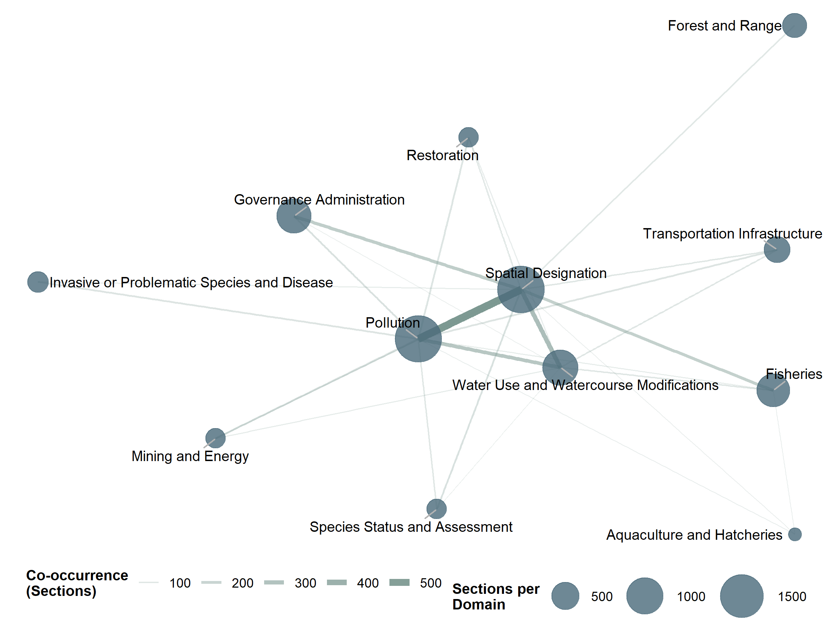
Figure 8: Management domain co-occurrence associations by section count.

Recovery potential assessments (RPA) and threat ranking case studies
The Committee on the Status of Endangered Wildlife in Canada (COSEWIC) assesses the status of wildlife species at risk in Canada, which is the first step in the process of listing a wildlife species under the Species at Risk Act (SARA). COSEWIC uses Designatable Units (DUs) to assess populations below the level of a recognized taxonomic species if the populations have attributes that make them both “discrete” and “evolutionarily significant” (COSEWIC 2023). COSEWIC outlines DUs within Pacific salmon species according to these criteria for the purposes of its status assessments of these species. When a DU under DFO’s responsibility is designated as threatened, endangered, or extirpated, a DFO-led Recovery Potential Assessment (RPA) process is initiated, which often includes a threat assessment using the same IUCN-CMP threat classification used in this legislative assessment.
DFO’s Wild Salmon Policy (WSP) outlines salmon management delineated by Conservation Units (CU), which are defined as: “a group of wild salmon sufficiently isolated from other groups that, if extirpated is very unlikely to recolonize naturally within an acceptable time frame, such as a human lifetime or a specified number of salmon generations” (DFO 2005). In most cases, DUs and CUs are equivalent with some lumping and splitting for specific populations. Any differences are explained within the RPA documents (DFO 2019, 2020; Mahony et al. 2019; Arbeider et al. 2020; Dionne 2023; Doutaz et al. 2023). Since the RPA population and habitat descriptions, along with corresponding threats, are conducted in the context of DUs, we incorporated DUs for the purpose of this study. We only included salmon populations with published RPAs (Table 5), and only RPA processes that used comparable IUCN-CMP threat categories. For example, Sakinaw Lake sockeye had an RPA published in 2019, but used a “limiting factor” analysis (Ramshaw et al. 2019), which did not align with this analysis.
Table 5: Designatable Units included in the DFO Recovery Potential Assessment analyses.
Species | DU Number | Designatable Unit | RPA Reference
Chinook | 1 | Southern Mainland Boundary Bay, Ocean, Fall population | Dionne et al. 2023
Chinook | 2 | Lower Fraser, Ocean, Fall (Harrison) | DFO 2020
Chinook | 4 | Lower Fraser, Stream. Summer (Upper Pitt) | DFO 2020
Chinook | 5 | Lower Fraser, Stream, Summer (Lillooet) | DFO 2020
Chinook | 6 | Lower Fraser, Ocean, Summer (Maria Slough) | Dionne et al. 2023
Chinook | 7 | Middle Fraser, Stream, Spring (FRCanyon) | DFO 2020
Chinook | 8 | Middle Fraser, Stream, Fall (Portage) | DFO 2020
Chinook | 9 | Middle Fraser, Stream, Spring | DFO 2020
Chinook | 10 | Middle Fraser,Stream, Summer | DFO 2020
Chinook | 11 | Upper Fraser, Stream, Spring | DFO 2020
Chinook | 13 | South Thompson, Stream, Summer | Dionne et al. 2023
Chinook | 14 | South Thompson, Stream, Summer (Bessette) | DFO 2020
Chinook | 15 | Lower Thompson, Stream, Spring | Dionne et al. 2023
Chinook | 16 | North Thompson, Stream, Spring | DFO 2020
Chinook | 17 | North Thompson, Stream, Summer | DFO 2020
Chinook | 69 | Okanagan River,Ocean, Summer | Mahony et al. 2021
Coho |  | Interior Fraser Coho | Arbeider et al. 2020
Sockeye | 2 | Bowron-ES population | Doutaz et al. 2023
Sockeye | 6 | Cultus-L population | DFO 2019
Sockeye | 10 | Harrison (U/S)-L population | Doutaz et al. 2023
Sockeye | 14 | North Barriere-ES population (original) | Doutaz et al. 2023
Sockeye | 16 | Quesnel-S population | Doutaz et al. 2023
Sockeye | 17 | Seton-L population | Doutaz et al. 2023
Sockeye | 20 | Takla-Trembleur-EStu population | Doutaz et al. 2023
Sockeye | 21 | Takla-Trembleur-Stuart-S population | Doutaz et al. 2023
Sockeye | 22 | Taseko-ES population | Doutaz et al. 2023
Sockeye | 24 | Widgeon (River-Type) population | Doutaz et al. 2023

The RPA process identified two IUCN-CMP threat categories as being an “Extreme” or “Extreme-High” ranking (Figure 9). 10.1 Geological Events received an extreme ranking, and 7.2 Dams & Water Management / Use received an extreme-high ranking. These two categories were chosen to assess the categories as case studies.
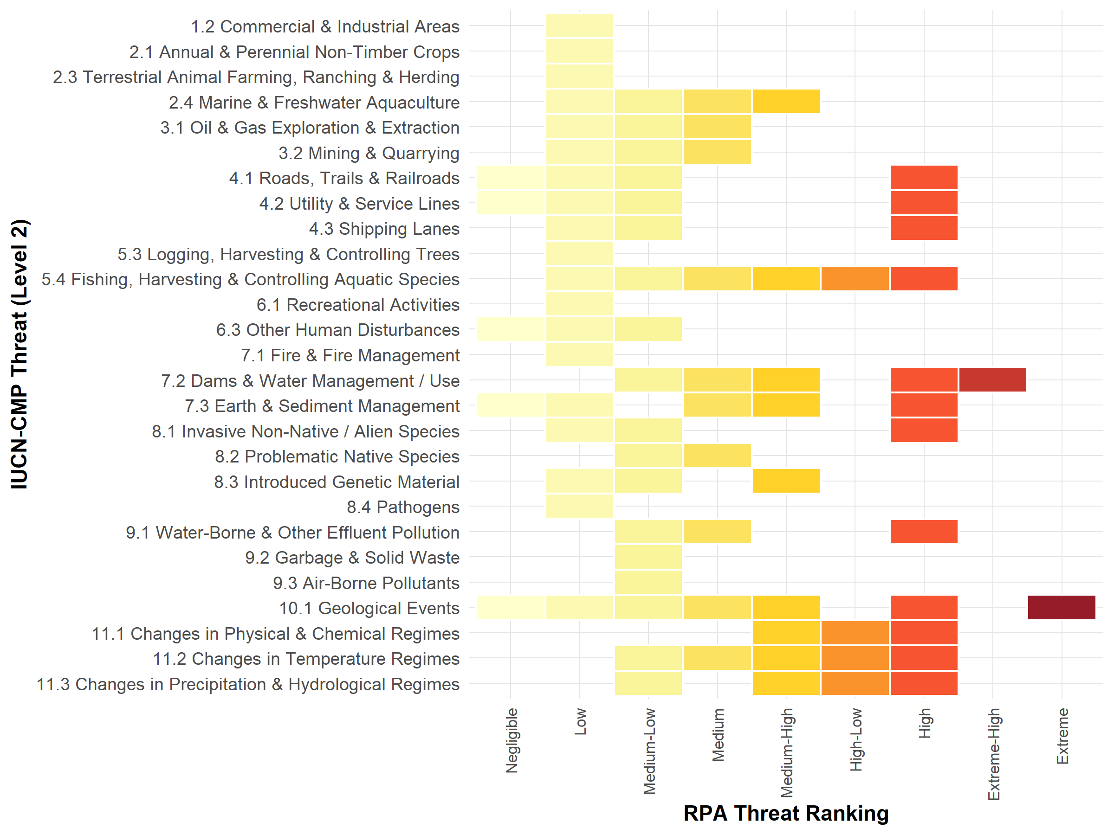
Figure 9: Threat ranking categories assigned by IUCN-CMP threat categories for Designatable Units of Pacific salmon assessed through the Recovery Potential Assessment process.
- Dan - the heatmap chart no longer shows a count for the number of DUs, it just lists the threat rankings available. I think that should help with the bias. I don’t list the “Unknown” values in this graphic, I’m making that an assumed category. But I could add the “Unknown” values and treat missing values like Pathogens as an “Unknown”? Let me know what you think.

Case Study: IUCN-CMP 10.1 Geological Events
Geologic events, specifically landslides, were rated as “Extreme” for three DUs of Fraser River Chinook and one DU of Fraser sockeye (Table 6; DFO (2020); Doutaz et al. (2023)). This ranking was largely due to a significant landslide on the Fraser River near Big Bar, British Columbia in late 2018 that blocked adult salmon upstream migration (DFO 2020; Doutaz et al. 2023). The published RPAs for these populations refer to this threat category as “Avalanches and Landslides” or “Geological events (Landslides).” Dionne (2023) references “IUCN-CMP threat category 10.2.” However, the most current IUCN-CMP Direct Threats Classification version 4.0 uses a slightly altered structure (Salafsky et al. 2024) where the the Level 2 threat is called 10.1 Geological Events, and avalanches and landslides are listed as examples of these events. We modified the classification of these assessments to fit the newest IUCN-CMP version for consistency.
Table 6: List of Pacific salmon Designatable Units where an 'Extreme' rating was assigned to the 10.1 Geological Events IUCN-CMP threat category through the RPA process.
Species | DU Number | Designatable Unit
Chinook | 9 | Middle Fraser, Stream, Spring
Chinook | 10 | Middle Fraser,Stream, Summer
Chinook | 11 | Upper Fraser, Stream, Spring
Sockeye | 20 | Takla-Trembleur-EStu population

The Big Bar landslide on the Fraser River in 2018 impacted approximately 80% of the Fraser salmon stocks (Doutaz et al. 2023). The blockage created a massive impediment to returning adult salmon, and occurred in a narrow and remote reach of the Fraser River where few options for mitigation were available. Landslides, in general, can occur naturally, but the severity and frequency can also be exacerbated by human activities such as landscape-scale changes and climate change (Doutaz et al. 2023). This indirect connection to human activities means that 10.1 Geological Events is not a large category to be matched with regulation. The LAPSE process and tool matched eight pieces of federal and provincial legislation specific to 10.1 Geological Events (Figure 6), largely related to forestry.
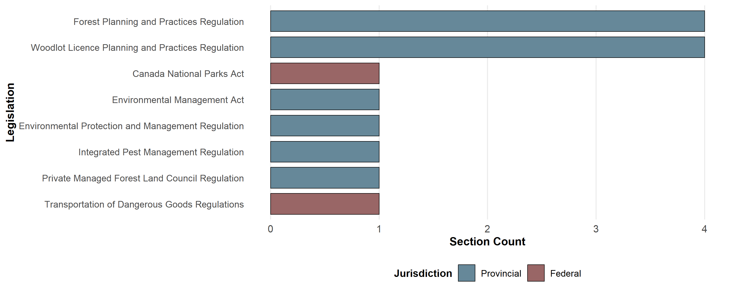
Figure 10: Count of sections by legislation for IUCN threat category 10.1 Geological Events, coloured by jurisdiction.
Users of the LAPSE process and tool who might be researching geological events such as landslides can get a list of possibly relevant legislation and will see that this legislation is mostly tied to forestry in British Columbia. As well, the user can see that the nature of the clauses are mostly “Instruction” and “Designation” (Figure 11). The provincial Forest Planning and Practices Regulation under the Forest and Range Practices Act appears as one of the most relevant statutes specific to landslides. Examples of matched sections include: Section 3, “Damage to the environment,” which states “(1)For the purpose of section 46 (1) and (1.1) [protection of the environment] of the Act, ‘damage’ means any of the following that adversely alters an ecosystem: (a)a landslide…” As well, Section 37, “Landslides,” states, “An authorized person who carries out a primary forest activity must ensure that the primary forest activity does not cause a landslide that has a material adverse effect in relation to one or more of the subjects listed in section 149 (1) of the Act.”
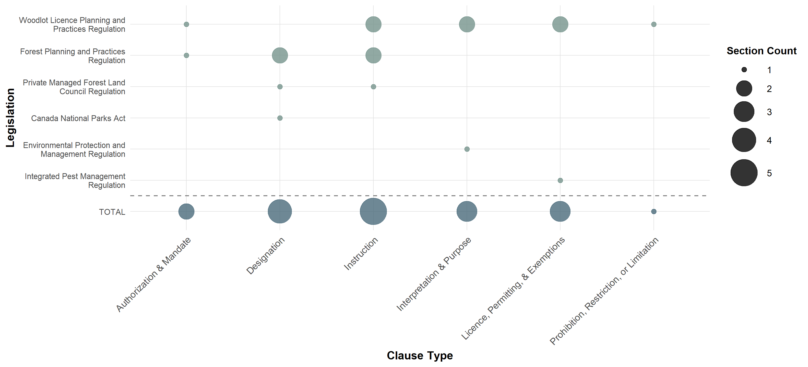
Figure 11: Section counts by clause type and legislation for IUCN-CMP threat category 10.1 Geological Events. Dot size represents section count.

Case Study: IUCN-CMP 7.2 Dams & Water Management / Use
The “Extreme-High” rating was applied to one threat category through DFO’s Recovery Potential Assessment processes. The Recovery Potential Assessment for 11 Designatable Units of Fraser River Chinook salmon, Oncorhynchus tshawytcha, Part 1: Elements 1 to 11 applied the rating to a threat category called “Natural systems modifications (Water management, ecosystems modifications),” which applies to one Fraser River Chinook DU: the South Thompson, Stream, Summer (Bessette) DU14 [@dfo2020]. The RPA provides a rationale specific to the Bessette Creek Chinook DU:
Groundwater extraction is of particular concern to stream-type Chinook Salmon as these populations are highly dependent on hyporheic and groundwater inputs for much of their freshwater residence. Hyporheic and groundwater upwelling protects redds from anchor-ice formation, maintains suitable temperatures for late-summer rearing habitats, moderates temperatures and water levels for returning adults, and creates thermal refugia. Despite the critical dependence of stream-resident salmonids on hyporheic and groundwater, in the past, groundwater extraction has not been actively managed. Surface water resources are also fully subscribed in many rivers, particularly in the arid southern interior. Water extraction is of particular concern for DU14 (STh-Bessette), which spawn in a drought-sensitive system in an area of extensive water extraction. Agricultural water use creates low summer flows and high stream temperatures to the point where fish kills have been recorded. The town of Lumby is a large contributor to groundwater extraction for the surrounding area, and water demands are expected to increase in the future. Due to the deficit of water caused by anthropogenic activities this threat was deemed to have a high to extreme level of impact on this population.
The IUCN-CMP Direct Threats Classification version 4.0 lists dam construction, dam operations, levees and dikes, channelization, highway culverts, wetland draining, water catchment areas, surface water withdrawals, and groundwater pumping as examples of 7.2 Dams and Water Management / Use, and no longer lists “Natural systems modifications” as a threat category. We followed the version 4.0 category structure for consistency and considered the “Natural systems modifications” as applying to 7.2 Dams and Water Management / Use since water extraction was described as the most significant factor for this threat in the RPA.
In contrast to the previous case study, 7.2 Dams and Water Management / Use is one of the largest categories found within the accumulated legislation, matching with 105 statutes, 814 sections, and 3117 clauses. However, just like the previous case study, the most relevant legislation is in the provincial jurisdiction (Figure 6), and the BC Water Sustainability Act stands out as the most relevant piece of legislation.
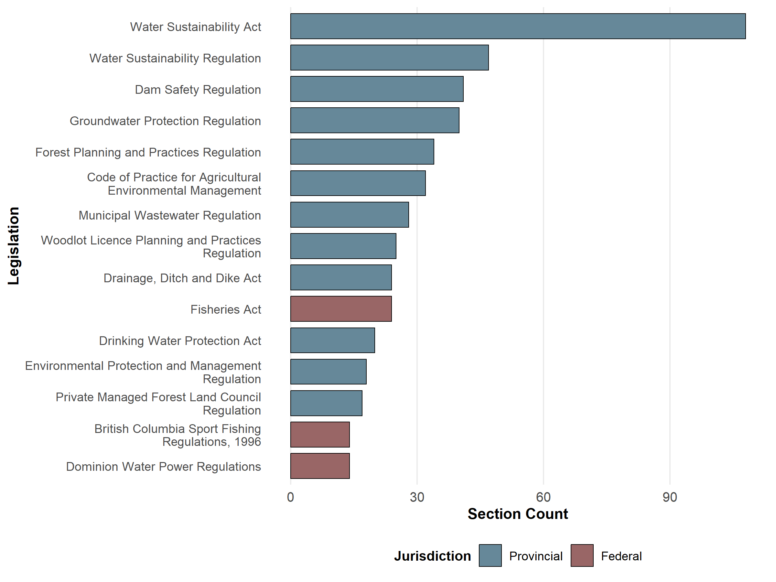
Figure 12: Count of sections by legislation for IUCN threat category 7.2 Dams & Water Management / Use, coloured by jurisdiction. Top 15 legislation shown.
The clause type matches for 7.2 Dams and Water Management / Use were much more evenly distributed likely due to the large number of clause matches in total for that IUCN-CMP threat category. “Interpretation & Purpose” matched the most clauses (includes Definition sections), while “Administration, Application, & Structure” matched the fewest clauses followed by “Prohibition, Restriction, or Limitation.”
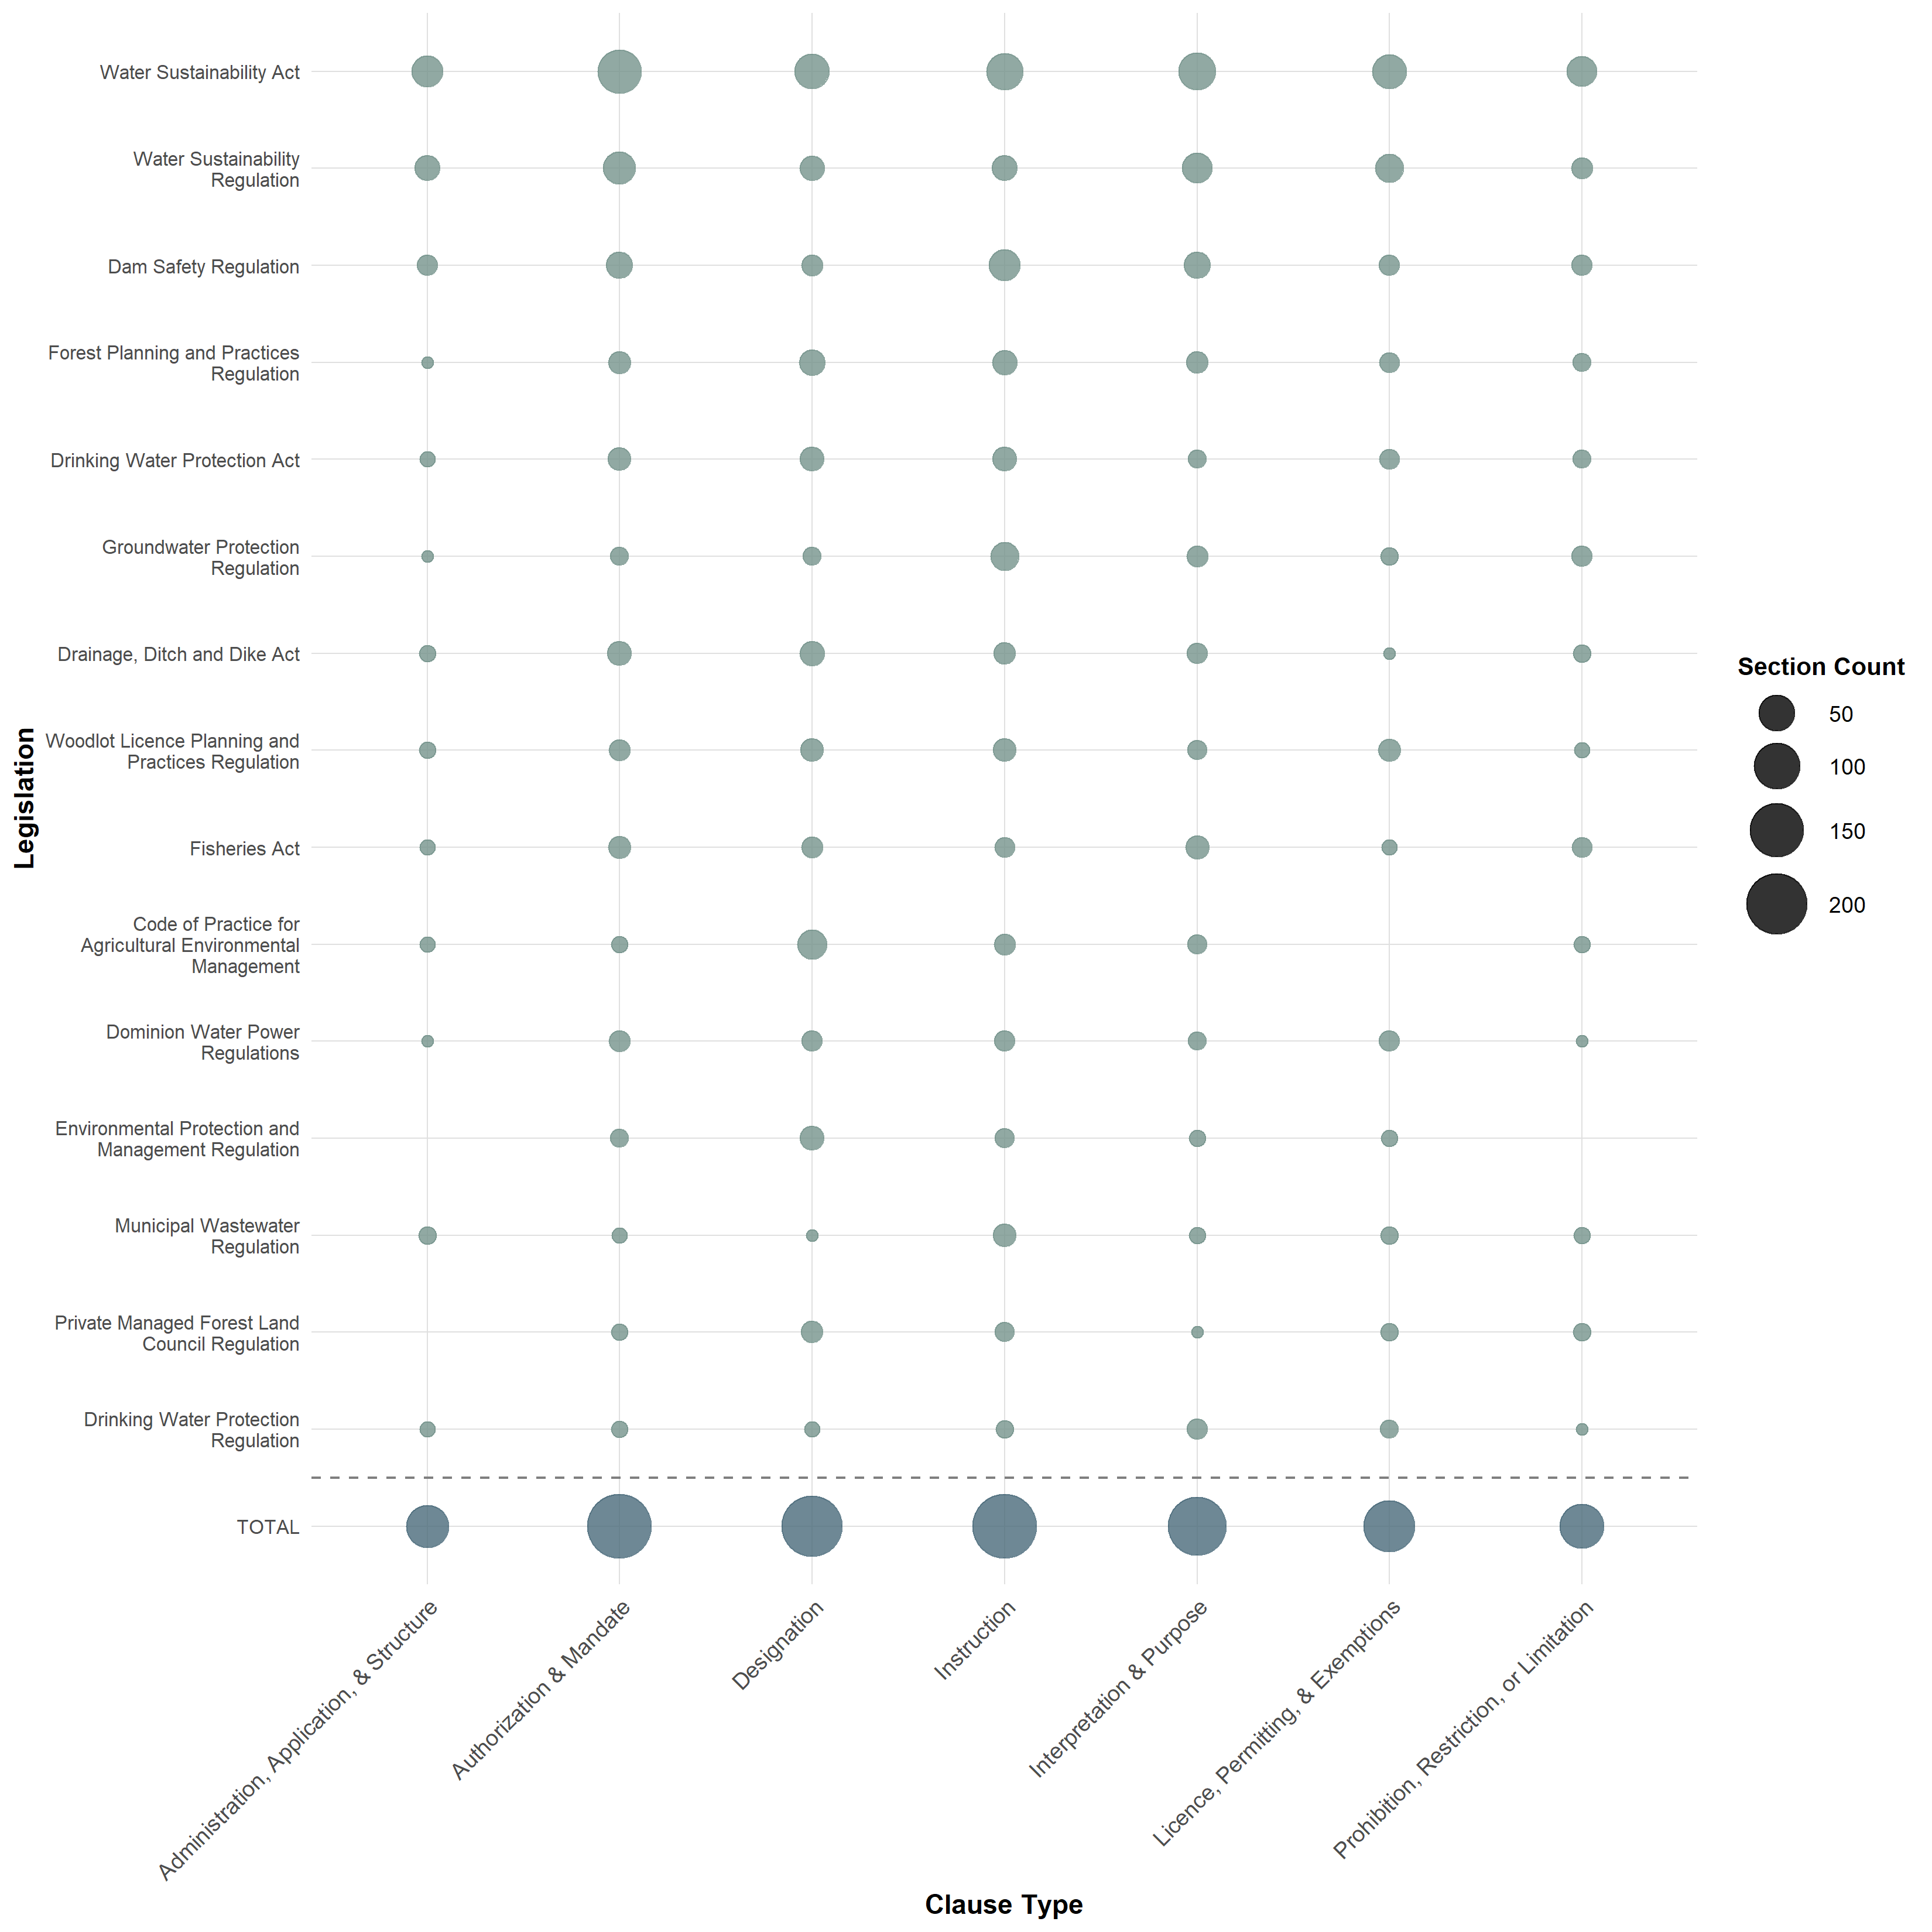
Figure 13: Section counts by clause type and legislation for IUCN-CMP threat category 7.2 Dams & Water Management / Use. Dot size represents section count. Top 15 legislation shown.
Users of the LAPSE process and tool researching water management and use would get a list of possibly relevant legislation, and would see that the top four matches are related to the BC Water Sustainability Act, including the Groundwater Protection Regulations. This outcome is supported by historic examples, especially in Bessette Creek watershed where the Province of British Columbia refused a groundwater use application using the Water Sustainability Act in 2016 citing environmental flow needs (McCleary and Thomson 2021). Both case studies show that the highest-ranking threats to Pacific salmon are governed mostly in the British Columbia provincial jurisdiction, while stock status and harvest allocations are determined federally. This relationship indicates the need for salmon stewardship to occur across collective jurisdictions.

Discussion
Socio-political boundaries at multiple spatial scales across a species’ range increase ambiguity regarding the ownership and regulation of space (Dallimer and Strange 2015). Federal parliament and provincial legislatures rely on broadly discretionary terms in statutes that appear protective (Collins and Sossin 2019), but may chronically fail to prevent environmental degradation (Bankes et al. 2014). One term can make the difference between a clause being mandatory or discretionary (“shall” as opposed to “may”), allowing an official to only exercise that authority or responsibility when economically feasible. The same laws that prohibit killing fish or damaging habitat also contain provisions to authorize those activities through licences, permits, and exemptions (Swerdfager and Olive 2023). This vagueness creates a large dependence on the executive to explain these implementation gaps (Bankes et al. 2014), allowing for arbitrary and somewhat dysfunctional stewardship styles lacking a broader overseer or responsible agency across the entire salmon life cycle.
Federal departments differ in how they implement the same legislation. For example, during the Species At Risk Act listing process, DFO conducts socio-economic analyses, whereas Environment and Climate Change Canada (ECCC) does not (Turcotte et al. 2021). These misaligned processes create a situation where even when a salmon population is assessed as “endangered” through COSEWIC such as the Cultus Lake and Sakinaw Lake sockeye (DFO (2019); Ramshaw et al. (2019)), the population could still be omitted from the List of Endangered Species (Government of Canada 2005) for economic and political reasons, denying the population larger legislative protections.

Conclusions
Pacific salmon stewardship projects (e.g. monitoring, restoration, enhancement, etc.) and decision processes often consider policies, methodologies, and literature, but the federal and provincial legislation that regulates human activities is not often reviewed. Legislative language can be vague and illusive, and the administrative structure of Pacific salmon jurisdiction in British Columbia is a decentralized and overlapping mosaic. The disconnect between legislative and natural resource language can lead to ineffective compliance with social values. The Legislation Applicable to Pacific Salmon and Ecosystems (LAPSE) process developed through this study attempts to bridge the language gap to equip practitioners with increased accessibility and navigability of the legal landscape.
The LAPSE tool provides a novel approach of linking legal language with salmon stewardship categorization by developing management domain categories based on internationally recognized biodiversity threat categories (IUCN-CMP threats). The methods developed to identify and match salmon management keywords and keyphrases to clauses allow for multiple outputs and opportunities including: an extensive list of legislation (acts, regulations, sections, and paragraphs) relevant to a human activity or salmon stewardship decisions; assessment of the nature or context of the statute (clause type) by management domain and threat; assessment of the overlap and connectedness in management domains (co-occurrence) to better understand the relationship between salmon threats in legislation. While this process and tool are relatively new and untested, further development could lead to a better integration of salmon stewardship decisions and administrative responsibility for such an important pillar of food security for communities across British Columbia.

References
Arbeider, M., Ritchie, L., Braun, D., Jenewein, B., Rickards, K., Dionne, K., Holt, C., Labelle, M., Nicklin, P., Mozin, P., Grant, P., Parken, C., and Bailey, R. 2020. Interior Fraser Coho Salmon Recovery Potential Assessment. Fisheries and Oceans Canada.
Atkinson, E.M., Carturan, B.S., Atkinson, C.P., Bateman, A.W., Connors, K., Hertz, E., and Peacock, S.J. 2024, December 5. Monitoring for fisheries or for fish? Declines in monitoring of salmon spawners continue despite a conservation crisis. doi:10.1101/2024.12.01.626233.
Bankes, N., Mascher, S., and Olszynski, M. 2014. Can Environmental Laws Fulfill Their Promise? Stories from Canada. Sustainability 6(9): 6024–6048. doi:10.3390/su6096024.
Becklumb, P. 2013. Federal and Provincial Jurisdiction to Regulate Environmental Issues. Library of Parliament, Canada, Ottawa, ON.
Bisson, P.A., Dunham, J.B., and Reeves, G.H. 2009. Freshwater Ecosystems and Resilience of Pacific Salmon: Habitat Management Based on Natural Variability. E&S 14(1): art45. doi:10.5751/ES-02784-140145.
Bogetti, J.M., and Mason, C.W. 2025. To protect or forget? Comparing species at risk legislation across Canada’s common-law provinces. FACETS 10: 1–11. doi:10.1139/facets-2025-0031.
Campbell, M.L., and Thomas, V.G. 2002. Constitutional Impacts on Conservation: Effects of Federalism on Biodiversity Protection. Environmental Policy and Law 32(5): 223–232. doi:10.3233/EPL-2002-32_5_13.
Canadian Legal Information Institute. 2025, December 18. CanLII. CanLII. Available from https://www.canlii.org/ [accessed 18 December 2025].
Chalifour, L., Holt, C., Camaclang, A.E., Bradford, M.J., Dixon, R., Finn, R.J.R., Hemming, V., Hinch, S.G., Levings, C.D., MacDuffee, M., Nishimura, D.J.H., Pearson, M., Reynolds, J.D., Scott, D.C., Spremberg, U., Stark, S., Stevens, J., Baum, J.K., and Martin, T.G. 2022. Identifying a pathway towards recovery for depleted wild Pacific salmon populations in a large watershed under multiple stressors. Journal of Applied Ecology 59(9): 2212–2226. doi:10.1111/1365-2664.14239.
Cohen, B.I. 2012. Commission of Inquiry into the Decline of Sockeye Salmon in the Fraser River (Canada): The uncertain future of Fraser River sockeye. Volume 3, Recommendations, summary, process : Final report. Privy Council Office, Minister of Public Works and Government Services Canada, Ottawa, ON. Available from https://publications.gc.ca/collections/collection_2012/bcp-pco/CP32-93-2012-3-eng.pdf.
Collins, L., and Sossin, L. 2019. Approach to Constitutional Principles and Environmental Discretion in Canada. Articles & Book Chapters 52(2740).
COSEWIC. 2023. COSEWIC guidelines for recognizing designatable units. COSEWIC guidelines for recognizing designatable units; Canadian Wildlife Service, Environment and Climate Change Canada, Gatineau, QC. Available from https://cosewic.ca/index.php/en/reports/preparing-status-reports/guidelines-recognizing-designatable-units.html.
Dallimer, M., and Strange, N. 2015. Why socio-political borders and boundaries matter in conservation. Trends in Ecology & Evolution 30(3): 132–139. doi:10.1016/j.tree.2014.12.004.
Del Valle, E., Neal, B., Martínez-Candelas, I., Dann, P., Webb, D., and McClenachan, L. 2024. Fishing in turbulent waters: Resilience, risk, and trust in British Columbia’s declining commercial salmon fishery. FACETS 9: 1–17. doi:10.1139/facets-2023-0204.
Department of Justice Canada. 2022, August 29. Legistics Paragraphing. Legistics Paragraphing. Available from https://www.justice.gc.ca/eng/rp-pr/csj-sjc/legis-redact/legistics/p3p1.html [accessed 18 December 2025].
Department of Justice Canada. 2026, January 13. Table of Public Statutes and Responsible Ministers. Table of Public Statutes; Responsible Ministers. Available from https://laws-lois.justice.gc.ca/PDF/tops/eng/TOPS.pdf [accessed 13 January 2026].
DFO. 2005. Canada’s policy for conservation of wild pacific salmon. Fisheries and Oceans Canada, Vancouver, BC. Available from https://waves-vagues.dfo-mpo.gc.ca/library-bibliotheque/315577.pdf.
DFO. 2019. Recovery Potential Assessment – Cultus Lake Sockeye Salmon (Oncorhynchus nerka). Science Advisory Report 2020/011. Canadian Science Advisory Secretariat.
DFO. 2020. Recovery Potentail Assessment for 11 Designatable Uits of Fraser River Chinook salmon, Oncorhynchus Tshawytcha, Part 1: Elements 1 to 11. DFO Can. Sci. Advis. Sec. Sci. Advis. Rep. Available from https://publications.gc.ca/collections/collection_2020/mpo-dfo/fs70-6/Fs70-6-2020-023-eng.pdf.
DFO. 2021. Wild Salmon Policy: 2018-2022 ImplementationPlan, Annual Report 2020-21. Fisheries; Oceans Canada, Vancouver, BC. Available from https://waves-vagues.dfo-mpo.gc.ca/library-bibliotheque/41031209.pdf.
DFO. 2022b. Rebuilding plan: Okanagan Chinook Salmon [Oncorhynchus tshawytscha] [ntytyix | sk’lwis]. Rebuilding plan: Okanagan Chinook Salmon [Oncorhynchus tshawytscha] [ntytyix | sk’lwis]; Fisheries and Oceans Canada, Ottawa, ON. Available from https://www.dfo-mpo.gc.ca/fisheries-peches/ifmp-gmp/salmon-saumon/2024/okanagan-2024-eng.html.
DFO. 2022a. Guidelines for writing rebuilding plans per the Fish Stocks Provisions and A Fishery Decision-making Framework Incorporating the Precautionary Approach. Guidelines for writing rebuilding plans per the Fish Stocks Provisions; A Fishery Decision-making Framework Incorporating the Precautionary Approach; Fisheries and Oceans Canada, Ottawa, ON. Available from https://www.dfo-mpo.gc.ca/reports-rapports/regs/sff-cpd/precautionary-precaution-eng.htm.
DFO. 2024. Trilateral declaration on the urgent need to address wild Pacific salmon populations in British Columbia. Trilateral declaration on the urgent need to address wild Pacific salmon populations in British Columbia; Fisheries and Oceans Canada. Available from https://www.pac.dfo-mpo.gc.ca/fm-gp/salmon-saumon/docs/trilat-agreement-accord/declaration-eng.html.
DFO. 2025. Rebuilding plan: West Coast of Vancouver Island Chinook, Oncorhynchus tshawystcha, Suuhaa | SȾOḰI | sat’sam. Fisheries and Oceans Canada, Vancouver, BC.
Dionne, K. 2023. Recovery potential assessment for southern British Columbian chinook populations, Fraser and southern mainland chinook designatable units (1, 6, 13 and 15). Canadian Science Advisory Secretariat (CSAS), Ottawa ON.
Doutaz, D., Ann-Marie Huang, Scott Decker, and Tanya Vivian. 2023. Recovery potential assessment for Fraser River sockeye salmon (Oncorhynchus nerka), nine designatable units part 2: Biology, habitat, threats, mitigations and allowable harm - elements 1-11, 14, 16-18, 22. Canadian Science Advisory Secretariat (CSAS), Ottawa ON.
Government of British Columbia. 2002. Forest and Range Practices Act. Available from https://www.bclaws.gov.bc.ca/civix/document/id/complete/statreg/02069_01.
Government of Canada. 2005. Order Giving Notice of Decisions not to add Certain Species to the List of Endangered Species. Available from https://laws-lois.justice.gc.ca/PDF/SI-2005-2.pdf.
Grant, S.C.H., Bronwyn L. MacDonald, and Mark L. Winston. 2019. State of the Canadian Pacific salmon: Response to changing climate and habitats. Department of Fisheries and Oceans, Nanaimo, British Columbia. Available from https://waves-vagues.dfo-mpo.gc.ca/library-bibliotheque/40807071.pdf.
Kraus, D., Murphy, S., and Armitage, D. 2021. Ten bridges on the road to recovering Canada’s endangered species. FACETS 6: 1088–1127. doi:10.1139/facets-2020-0084.
Mahony, A., Challenger, W., Robichaud, D., Wright, H., Bussanich, R., Sharma, R., and Enns, J. 2019. Recovery Potential Assessment for the Okanagan Chinook Salmon (Oncorhynchus tshawytscha) (2019).
Marentette, J.R., and Kronlund, A.R. 2020. A cross-jurisdictional review of international fisheries policies, standards and guidelines: Considerations for a Canadian Science Sector approach. Fisheries and Oceans Canada = Pêches et Océans Canada, Ottawa, ON.
McCleary, R.J., and Thomson, D.A. 2021. Hydrogeology and Environmental Flow Needs Assessment of a Groundwater Licence Application near Lumby, B.C. Province of British Columbia, Victoria, BC. Available from https://a100.gov.bc.ca/pub/acat/documents/r59109/BessetteCreekCaseStudy_1618261345167_93488C355C.pdf.
McCune, J.L., Harrower, W.L., Avery-Gomm, S., Brogan, J.M., Csergő, A.-M., Davidson, L.N.K., Garani, A., Halpin, L.R., Lipsen, L.P.J., Lee, C., Nelson, J.C., Prugh, L.R., Stinson, C.M., Whitney, C.K., and Whitton, J. 2013. Threats to Canadian species at risk: An analysis of finalized recovery strategies. Biological Conservation 166: 254–265. doi:10.1016/j.biocon.2013.07.006.
McDonald, K. 2021. Pacific Salmon: Ensuring the Long-term Health of Wild Populations and Associated Fisheries. House of Commons Canada, Ottawa, ON. Available from https://publications.gc.ca/collections/collection_2021/parl/xc51-1/XC51-1-1-432-5-eng.pdf.
Minister of Justice Canada. 1985. Fisheries Act. Available from https://laws-lois.justice.gc.ca/PDF/F-14.pdf.
Moore, J.W., Ulaski, M.E., Wilson, K.L., Martin, T.G., Kuiper, S.D., Peacock, S.J., Braun, D.C., Naman, S.M., Pitman, K.J., Reid, A.J., Rosenfeld, J.S., Sainsbury, N.C., Wilson, S.M., and Zdasiuk, B.J. 2025. A Safe Operating Space for Salmon Watersheds Under Rapid Climate Change. Fish and Fisheries 26(6): 1213–1228. doi:10.1111/faf.70027.
Price, M.H.H., English, K.K., Rosenberger, A.G., MacDuffee, M., and Reynolds, J.D. 2017. Canada’s Wild Salmon Policy: An assessment of conservation progress in British Columbia. Can. J. Fish. Aquat. Sci. 74(10): 1507–1518. doi:10.1139/cjfas-2017-0127.
Province of British Columbia. 2025. Acts - Ministers’ Responsibilities. Government of British Columbia. Available from https://www.bclaws.gov.bc.ca/civix/content/amr/amr/2067365574/?xsl=/templates/browse.xsl.
Ramshaw, B., Luedke, W., and Korman, J. 2019. Recovery Potential Assessment for the Sakinaw Lake Sockeye Salmon (Oncorhynchus nerka) (2017). In ix. DFO Can. Sci. Advis. Sec. Res. Doc. Available from https://publications.gc.ca/collections/collection_2018/mpo-dfo/fs70-6/Fs70-6-2018-042-eng.pdf.
Ray, J.C., Grimm, J., and Olive, A. 2021. The biodiversity crisis in Canada: Failures and challenges of federal and sub-national strategic and legal frameworks. FACETS 6: 1044–1068. doi:10.1139/facets-2020-0075.
Salafsky, N., Relton, C., Young, B.E., Lamarre, P., Böhm, M., Chénier, M., Cochrane, E., Dionne, M., He, K.K., Hilton‐Taylor, C., Latrémouille, C., Morrison, J., Raymond, C.V., Seddon, M., and Suresh, V. 2024. Classification of direct threats to the conservation of ecosystems and species 4.0. Conservation Biology 39(3): e14434. doi:10.1111/cobi.14434.
Salafsky, N., Salzer, D., Stattersfield, A.J., Hilton‐Taylor, C., Neugarten, R., Butchart, S.H.M., Collen, B., Cox, N., Master, L.L., O’Connor, S., and Wilkie, D. 2008. A Standard Lexicon for Biodiversity Conservation: Unified Classifications of Threats and Actions. Conservation Biology 22(4): 897–911. doi:10.1111/j.1523-1739.2008.00937.x.
Swerdfager, T., and Olive, A. 2023. Laws matter: A foundational approach to biodiversity conservation in Canada. FACETS 8: 1–13. doi:10.1139/facets-2022-0095.
Thompson, P.C. 1974. Institutional Constraints in Fisheries Management. J. Fish. Res.Board Can (31): 1965–1981.
Turcotte, A., Kermany, N., Foster, S., Proctor, C.A., Gilmour, S.M., Doria, M., Sebes, J., Whitton, J., Cooke, S.J., and Bennett, J.R. 2021. Fixing the Canadian Species at Risk Act : Identifying major issues and recommendations for increasing accountability and efficiency. FACETS 6: 1474–1494. doi:10.1139/facets-2020-0064.
Ulaski, M.E., Moore, J.W., Carlson, D., Taddei, K.F., Kriese, K., Griggs, J., Murray, C.C., Adams, M., Wilson, K.L., Reid, A., Sainsbury, N., Cannon, S., Griggs, E., and Martin, T.G. 2025. Barriers and opportunities for the effective management of cumulative effects in salmon ecosystems in British Columbia, Canada. FACETS 10: 1–25. doi:10.1139/facets-2024-0348.
Wickham, H. 2025. Rvest: Easily Harvest (Scrape) Web Pages. doi:10.32614/CRAN.package.rvest.
Wijffels, J. 2025. Udpipe: Tokenization, Parts of Speech Tagging, Lemmatization and Dependency Parsing with the ’UDPipe’ ’NLP’ Toolkit. doi:10.32614/CRAN.package.udpipe.

Supplementary material
- Links or downloads for the LAPSE tool materials (app etc.)

